COMSATS University Islamabad (CUI)

**Software Requirement Specification**

**(SRS DOCUMENT)**

# for Content Flow

Version 1.0

***By***

**Adnan khalil SP22-BSE-002**

**Muhammad Asif SP22-BSE-030**

***Supervisor***

**Ms. Hafiza Sundas**

***Bachelor of Science in Computer Science (2022-2026)***

**Revision History**

|  |  |  |  |
| --- | --- | --- | --- |
| **Name** | **Date** | **Reason for Changes** | **Version** |
|  |  |  |  |
|  |  |  |  |
|  |  |  |  |
|  |  |  |  |
|  |  |  |  |
|  |  |  |  |

**Application Evaluation History**

|  |  |
| --- | --- |
| **Comments (by committee)**  **\*include the ones given at scope time both in doc and presentation** | **Action Taken** |
|  |  |
|  |  |
|  |  |
|  |  |
|  |  |

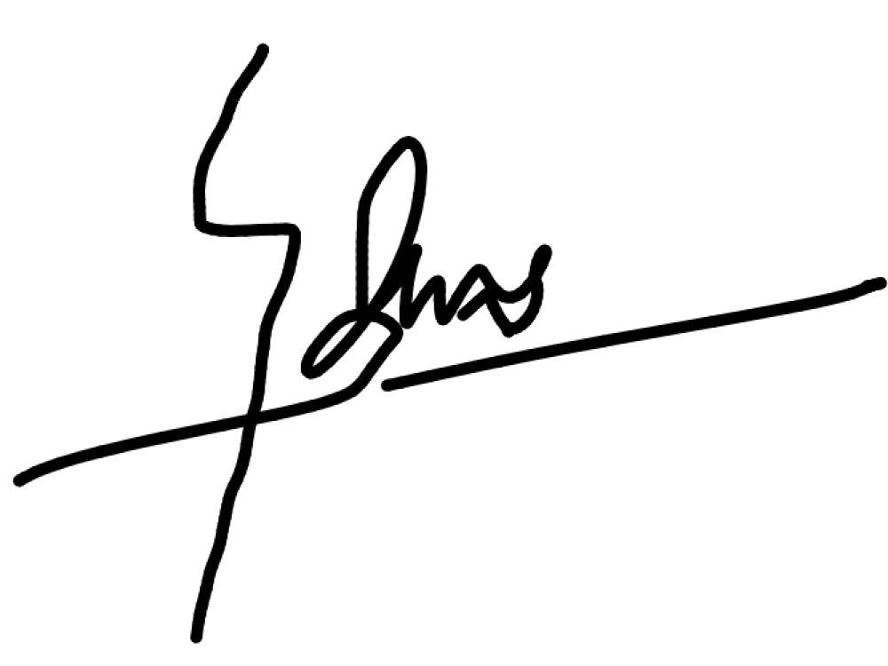**Supervised by**

**Ms. Hafiza Sundas**

Signature

Table of Contents

for Content Flow 1

1. Introduction 8

1.1 Purpose 8

1.2 Scope 8

1.3 Modules 9

Module 1: AI-Enhanced Media Module 9

Module 2: Post Creation & Scheduling Module 9

Module 3: Post Analytics Module 9

Module 4: User Registration & Subscription Module 9

Module 5: Multi-Platform Posting Module 9

Module 6: Subscription & Payment Module 9

Module 7: Ad Generation Module 9

Module 8: E-mailing and notification Module 10

1.4 Overview 10

2. Overall Description 10

2.1 Product Perspective 10

2.2 User classes and characteristics 11

2.3 Operating Environment 12

2.4 Design and Implementation Constraints 12

3. Requirement Identifying Technique 13

3.1 Use Case Diagram: 13

3.2 Detail Use Case: 15

3.2.1 Register Account 15

3.2.2 Select Subscription 16

3.2.3 Link Social Media 17

3.2.4 Draft Post 18

3.2.5 Recommend Background Music 19

3.2.6 Generate AI Hashtags 20

3.2.7 Edit Post 21

3.2.8 Preview Post 22

3.2.9 Schedule Post 23

3.2.10 Select Ad Template 24

3.2.11 Generate Template 25

3.2.12 AI-Made Template 26

3.2.13 Self-Made Template 27

3.2.14 Customize Ad 28

3.2.15 Export Ad 29

3.2.16 Schedule Ad 30

3.2.17 Upload Post 31

3.2.18 Filter Analytics 32

3.2.19 View Engagement Metrics 33

3.2.20 Analyze Audience 34

3.2.21 User Management 35

3.2.22 Logout 36

3.2.23 Verify Email 37

3.2.24 Verify Payment 38

3.2.25 Link Social Media Platform 39

3.2.26 Auto-Format Post per Platform 40

3.2.27 Handle Posting Errors 41

3.2.28 Post Scheduling Alerts 42

3.2.29 Request Report of Invoice 43

3.2.30 Subscription Renewal Reminder 44

3.2.31 Email & Notifications 45

3.3 Event response table: 46

4. Functional Requirements 47

4.1 UC-1 Register Account 47

4.1.1 Account Register 47

4.1.2 Account.Validate 47

4.1.3 Account.Invalid.Username 48

4.1.4 Account.Invalid.Email 48

4.1.5 Login.Information 48

4.1.6 Login.Information.Valid 49

4.1.7 Login.Information.Invalid 49

4.1.8 Login.Information.Valid 49

4.1.9 Password.Reset 50

4.1.10 Password.Reset.EmailInput 50

4.1.11 Password.Reset.Validate 50

4.1.12 Password.Reset.Invalid 51

4.1.13 Password.Reset.Information 51

4.1.14 Password.Reset.New 51

4.1.15 Password.New.Validate 52

4.1.16 Password.New.Valid 52

4.1.17 Password.New.Invalid 52

4.2. UC-2 Select Subscription 53

4.2.1 Subscription.Free 53

4.2.2 Subscription.Paid 53

4.2.3 Subscription.Paid.FreeTrial 53

4.2.4 Subscription.Paid.Pay 54

4.3. UC-3 Link Social Media 54

4.3.1 Link.Facebook 54

4.3.2 Link.Instagram 54

4.3.3 Link.Twitter 55

4.3.4 Link.SaveAccounts 55

4.3.5 Link.Facebook.Delete 55

4.3.6 Link.Instagram.Delete 56

4.3.7 Link.Twitter.Delete 56

4.3.8 Link.Facebook.change 56

4.3.9 Link.Instagram.change 57

4.3.10 Link.twitter.change 57

4.4. UC-4 Draft Post 57

4.4.1 Draft Post.Import from Gallery 57

4.4.2 Draft Post.Import from Drive 58

4.5. UC-5 Recommend Music 58

4.5.1 Recommend Music.Analyze 58

4.5.2 Recommend Music.Analyze.Seach Trending 58

4.5.3 Recommend Music.Analyze.Seach Trending.Appply Music 59

4.6. UC-6 Recommend Hashtags 59

4.6.1 Recommend Hashtags.Analyze 59

4.6.2 Recommend Hahtags.Analyze.Seach Trending 59

4.6.3 Recommend Hashtags.Analyze.Seach Trending.Appply Hahtags 60

4.7. UC-7 Edit Post 60

4.7.1 Edit Post.Erase Background 60

4.7.2 Edit Post.Crop 60

4.7.3 Edit Post.Set Brightness 61

4.7.4 Edit Post.Increase Quality 61

4.7.5 Edit Post.Set Contrast 61

4.7.6 Edit Post.Set Visibility 62

4.7.7 Edit Post.Set Frame 62

4.8. UC-8 Preview Post 62

4.8.1 Preview Post.Set Background Music 62

4.8.2 Preview Post.Set Hashtags 63

4.8.3 Preview Post.Set Location 63

4.8.4 Preview Post.Tag Friends 63

4.8.5 Preview Post.View as Dummy Post 64

4.9 UC-9 Schedule Post 64

4.9.1 Schedule Post.Select Post 64

4.9.2 Schedule Post.Select Time 64

4.9.3 Schedule Post.Select Day 65

4.9.4 Schedule Post.Select Date 65

4.9.5 Schedule Post.Select Platform 65

4.9.6 Schedule Post.Post on Platform 66

4.9.7 Schedule Post. Delete Scheduled Post 66

4.9.8 Shedule Post.Change Time and Date of Scheduled Post 66

4.9.9 Schedule Post.Change Social Platform of Posting 67

4.9.10 Schedule Post. Reschedule the Post 67

4.10 UC-10 Select Ad Template 67

4.10.1 Select Ad Template.View All Templates 67

4.10.2 Select Ad Template.Filter Templates 68

4.10.3 Select Ad Template.Select Template 68

4.11 UC-11 Generate Templete 68

4.11.1 Generate Templete.AI-Driven Ad Template 68

4.12 UC-14 Customize Ad 69

4.12.1 Customize Ad.Modify Text & Fonts 69

4.12.2 Customize Ad.Add & Replace Images 69

4.12.3 Customize Ad.Adjust Colors & Themes 70

4.13 UC-15 Export Ad 70

4.13.1 Export Ad.Select Export Format 70

4.13.2 Export Ad.Download Ad File 70

4.13.3 UC-16 Schedule Ad Post 71

4.14 UC-17 Ad Notification Through Email 71

4.14.1 Ad Notification.Notify Scheduled Post 71

4.14.2 Ad Notification.Analytics Update Notification 71

4.14.3 Ad Notification.Subscription Renewal Reminder 72

4.15 UC-18 Analytics Module 72

4.15.1 Analytics Module.Track Likes 72

4.15.2 Analytics Module.Track Share 72

4.15.3 Analytics Module.Track Comment 73

4.15.4 Analytics Module.Track Views 73

4.15.5 Analytics Module.Generate Performance Charts 73

4.15.6 Analytics Module.Compare Posts Performance 74

4.16 UC-21 User Management 74

4.16.1 User Management.Update Profile 74

4.17 UC-22 Logout 74

4.17.1 Logout.Manual Logout 74

4.17.2 Logout. Auto Logout After Inactivity 75

4.17.3 Logout.Logout from All Devices 75

4.17.4 Logout. Logout Confirmation Prompt 75

4.18 UC-23 Verify Regestration 76

4.18.1 Verify Regestration.Send Verification Email 76

4.18.2 Verify Regestration.Confirm Email Verification 76

4.19 UC-24 Verify Payment 76

4.19.1 Verify Payment.Validate Payment Details 76

4.19.2 Verify Payment. Process Payment Transaction 77

4.20 UC-25 Link Social Media Platforms 77

4.20.1 Link Social Media Platforms.Authorize Social Media Account 77

4.20.2 Link Social Media Platforms. Manage Linked Accounts 77

4.21 UC-26 Auto-Format Post per Platform 78

4.21.1 Auto-Format.Adjust Image Dimensions 78

4.22 UC-27 Handle Posting Errors 78

4.22.1 Handle Posting Errors.Detect Posting Errors 78

4.22.2 Handle Posting Errors.Suggest Fixes for Errors 78

4.23 78

4.24 UC-28 Post Scheduling Alert 79

4.24.1 Post Scheduling Alert.Send Pre-Scheduled Post Notification 79

4.24.2 Post Scheduling Alert.Post Alert Settings 79

4.25 UC-30 Email & Notifications 79

4.25.1 Send Email Notifications 79

4.26 UC-31 Subscription Renewal Reminder 80

4.26.1 Subscription Renewal. Generate Renewal Notification 80

4.26.2 Subscription Renewal. Send Payment Reminder Email 80

5. Non-Functional Requirements 81

5.1. Reliability 81

5.2. Usability 81

5.3. Performance 81

5.4. Security 81

6. External Interface Requirements 82

6.1. User Interfaces Requirements 82

6.2. Software interfaces 85

6.3. Hardware interfaces 86

6.4. Communications interfaces 86

7. References 86

8. Plagiarism Report 87

# Introduction

Content Flow is a social media management application designed for content creators, marketers, and businesses who want to handle the entire content preparation workflow in one place.

This project proposal outlines what Content Flow is about. The AI-powered features such as autogenerated hashtags for pictures, music recommendations, and photo ad creation with certain templates taken from a predefined option can improve the quality of content and maximize audience engagement on the platform. Content Flow uses AI-driven functionalities such as automatic hashtag generation for images, music suggestions, and photography advertisements built upon pre-set templates to augment all elements of media and audience interaction.

To make automation a reality, the platform holds onto all management utilities for posting content at once from a single portal to post, which can be scheduled or tracked on different social sharing platforms and these ultimately gain time spent per task. With a subscription model, premium features allow you to create bespoke content fast and with maximum impact, augmented by detailed data driven analytics.

## Purpose

**Content Flow** combines content creation, scheduling, and analytics in a single platform with an AI-powered social media management solution that covers up these challenges. There are features such as auto-generated hashtags, music recommendation, and creation of AI-driven photo ads based on customizable templates that a user can use to upgrade his/her content to an extent with minimal manual effort. This limits the hours and efforts spent coming up with interesting posts, thereby making way for more efforts in relationship building with the target audience. Using the app, such an option is available in the scheduling of posts to be made at what time for maximum visibility and engagement across all media-social channels.

Apart from content generation and scheduling, Content Flow provides in-depth analytics through graphical insights and charts so users may track performance metrics to refine their strategies accordingly. The earlier subscription model of premium features has now been extended to include user customization as well as comprehensive analytics. Content Flow is the resource that can bring together every necessary task at social media into one and give a user the facility to make his output more streamlined, so it reaches more people and influences to a greater extent. This does make the resource valuable for anyone who wants to enhance their social media presence in an efficient manner.

## Scope

The Content Flow has been designed to provide a single, unified solution for content management, scheduling, and tracking in content for social media. It implements AI-driven tools, such as hashtag generation, music recommendations, and photo ad creation based on event-specific templates. With the analytics module available in the app, you track what's engaged with and even find out if there are trends. Lock-in premium features with the subscription model to have more comprehensive options for your customization and insights into your analytics.

## Modules

### Module 1: AI-Enhanced Media Module

**FE-1:** The system shall generate an auto-response of appropriate hashtags.

**FE-2:** The system shall provide background music for posts depending upon the mood or theme of the post.

**FE-3:** For any user-selected template, the system shall develop photo ads by AI.

**FE-4:** Provide suggestions to improve the appearance of posts with the enhancement of aesthetics of posts, such as filters, image adjustments, and others.

### Module 2: Post Creation & Scheduling Module

**FE-1:** This system will allow the user to write, edit and save articles for later publication.

**FE-2:** The system must provide the feature of scheduling of post.

**FE-3:** The system shall offer preview of posts in the form of real-time view.

**FE-4.** The system will offer a content editor for text formatting, image uploads, and media customization.

### Module 3: Post Analytics Module

**FE-1:** The application must enable every post to display engagement metrics.

**FE-2:** The system shall provide, appropriate to the type of visualization analytics, with graphical output of charts and graphs, showing post-performance over time. **FE-3**. The demographic data (age, location, gender) of the involved users shall be processed and presented by the application.

**FE-4:** The system shall offer users the feature of filtering analytics data.

### Module 4: User Registration & Subscription Module

**FE-1:** The system shall allow a new user to sign up with his own details.

**FE-2:** The system shall allow a user to select different subscription plans available at the time of registration or later.

**FE-3:** The system shall allow providing an account management interface where users view and update their information profiles.

**FE-4.** Validate the mail addresses inputting as well as send the activation verification messages to those accounts.

### Module 5: Multi-Platform Posting Module

**FE-1:** The system shall allow the user to link up his/her social media accounts.

**FE-2:** The system should allow the user to select more than one platform while creating or scheduling a post.

**FE-3** Posts will be formatted and general guidelines tailored for each of the platform. **FE-4**: The system shall be able to throw error messages if, at any stage of posting, any platform encounters a problem.

### Module 6: Subscription & Payment Module

**FE-1:** The system shall provide available subscription plans to the users with the respective details and prices.

**FE-2** The payment system shall provide safe payment alternatives by including credit/debit cards, and any other popular Internet payment scheme.

**FE-3:** The system shall automatically recharge subscriptions if users have opted for the auto-recharge feature.

**FE-4:** The system will generate and print invoices for each successful payment.

### Module 7: Ad Generation Module

**FE-1:** Pre-designed templates shall be provided by the system so users can compose photo ads.

**FE-2:** The system shall provide users with the ability to input custom text and choose color schemes for personalizing ads.

**FE-3:** The system will utilize AI in the adjustment of layouts and designs with regard to input coming from users as well as their preferred selections of the template.

**FE-4:** The system shall enable the export of generated ads in any image format, such as: (JPEG or PNG).

### Module 8: E-mailing and notification Module

**FE-1:** The system will send an email to users who have scheduled posts, need subscription renewals, and system updates.

**FE-2:** The application should be able to issue the following types of notifications: important updates analytics summaries post status changes.

**FE-3:** Users should be able to customize the system which sends both email and in-app notifications about how those notifications are presented.

**FE-4** The system should automatically send reminders to posts scheduled within 24 hours and for subscription renewal, one week in advance before expiration.

## Overview

This Software Requirements Specification (SRS) document provides a detailed description of the functional and non-functional requirements for the Content Flow System. It defines the system’s purpose, scope, and intended users, ensuring a clear understanding of the system’s functionalities and constraints.

# Overall Description

This section presents a high-level overview of the product and the environment in which it will be used, the anticipated users, and known constraints, assumptions, and dependencies.

## Product Perspective

The **Content Flow System** is a **new product** designed to assist users in creating, scheduling, and managing digital content, particularly advertisements and social media posts. The system integrates AI-based tools for content enhancement, such as AI-generated hashtags, background music recommendations, and customizable ad templates. It is a standalone system that interacts with various external services for authentication, social media integration, and media processing. The system will allow users to register, draft, edit, schedule, and post content on multiple platforms while offering AI-enhanced advertising solutions. A **context diagram** illustrating the system’s relationship with external entities (e.g., users, social media platforms, AI processing services) can be found in **Figure 1.**

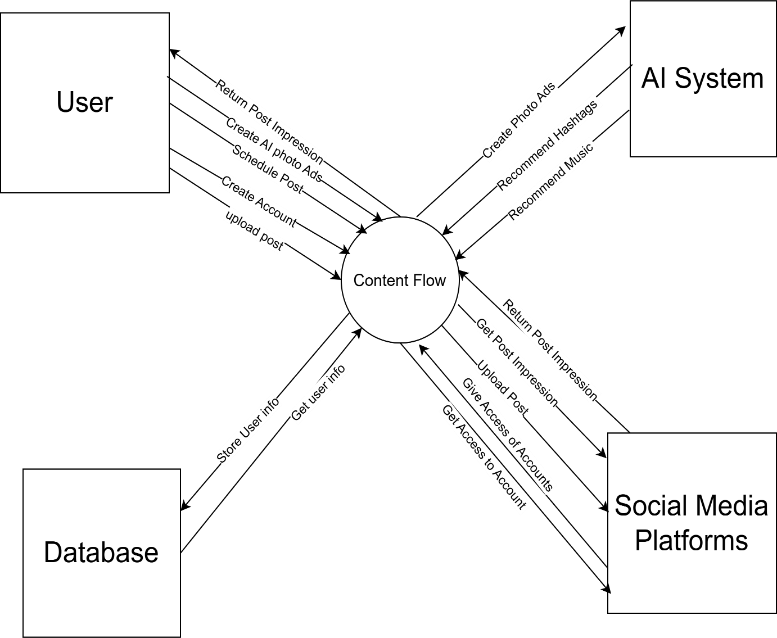

**Figure 1: Context Diagram**

## User classes and characteristics

|  |  |
| --- | --- |
| **Actor** | **Characteristics** |
| **Content Creator**  **(Primary User)** | User Can register an account and link social media.  Draft, edit, and preview posts.  Use AI-based recommendations (hashtags, background music).  Select ad templates and customize ads.  Schedule posts and ads for later publishing.  Export ads to external platforms. |
| **AI Recommendation System**  **(Automated)** | Suggests background music based on content type.  Provides AI-generated hashtags for better engagement.  Assists in auto-generating ad templates based on selected themes. |
| **Social Media Platforms**  **(External Systems)** | Receives scheduled posts from the system.  Integrates via APIs to fetch user’s linked accounts.  Allows direct posting based on scheduled times. |

## Operating Environment

1. **OE-1**: The system shall operate correctly with the following web browsers: Windows Internet Explorer versions 7, 8, and 9; Firefox versions 12 through 26; Google Chrome (all versions); and Apple Safari versions 4.0 through 8.0.
2. **OE-2**: The system shall support operation on Windows, macOS, and Linux-based operating systems without requiring additional software installations.
3. **OE-3**: The system shall store user data in a secure cloud-based database with regular backups to prevent data loss.
4. **OE-4**: The system shall integrate with social media platforms (such as Facebook, Instagram, and Twitter) through their respective APIs for content posting and authentication.

## Design and Implementation Constraints

1. **CON-1**: The system shall use **MongoDB** as the database engine
2. **CON-2**: The application must be developed using **Node.js and Express.js** for the backend.
3. **CON-3**: The frontend of the system shall be built using **React.js with Tailwind CSS**.
4. **CON:4**: The machine learning, natural language processing and web scraping scripts shall be written in Python 3.13
5. **CON-5:** The system shall only support online transactions via **Stripe and PayPal** due to their secure and widely accepted payment processing mechanisms.
6. **CON-6**: The authentication and user verification system shall use **JWT (JSON Web Token) and OAuth 2.0**, ensuring secure and token-based authentication for all users.
7. **CON-7**: All textual data, including user posts and metadata, shall be stored in **JSON format** for better data exchange between the frontend and backend.

# Requirement Identifying Technique

The first technique used in identifying requirements for the system is use cases. Content Flow has a lot of user involvement, and the user requirements are identified using this technique. The use case diagram representing the requirements of each user is given below. Detailed use cases are also present in the following sections.

### Use Case Diagram:

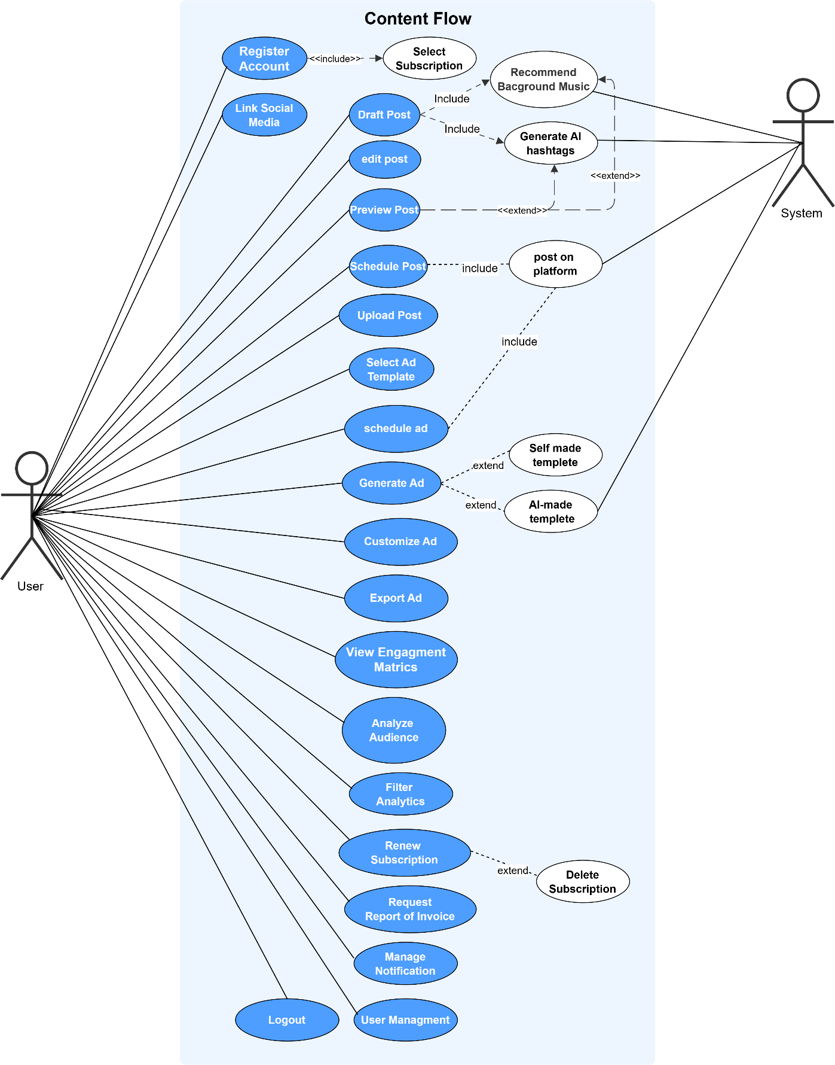

**Figure 2: Use Case Diagram of User**

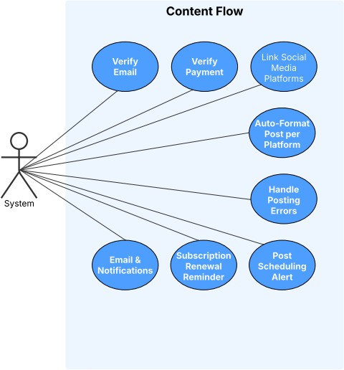

**Figure 3: Use Case Diagram of System**

### Detail Use Case:

### Register Account

|  |  |
| --- | --- |
| **Use Case ID:** | UC-1 |
| **Use Case Name:** | Register Account |
| **Actors:** | Primary actor: user |
| **Description:** | A new user can create an account by providing required information, which the system validates and stores. |
| **Trigger:** | User clicks on the **"Sign Up"** button on the homepage or login page. |
| **Preconditions:** | User is not already registered. |
| **Postconditions:** | User account is created and stored. |
| **Normal Flow:** | 1.0 Register account   1. User click “sing up” button. 2. System prompts for details. 3. User enters ID and password. 4. System validates inputs. 5. System confirms registration. |
| **Alternative Flows:** | 1.0 Invalid Email Format:   1. User enters an invalid email format. 2. System prompts the user to correct the email. 3. User corrects the email format. 4. System resumes from 1.0 normal flow step 2.   1.1 Password Mismatch:   1. User enters mismatched passwords. 2. System notifies the user to re-enter matching passwords. 3. User re-enters matching passwords. 4. System resumes from normal flow step 2. |
| **Exceptions:** | E1: A network failure disrupts the registration process. E2: User submits invalid data causing form rejection. |
| **Business Rules** | BR-1: Users must provide a valid email and password. BR-2: Email addresses must be unique.  BR-3: Passwords must meet complexity requirements. |
| **Assumptions:** | 1. Users have access to a valid email. 2. Users can complete CAPTCHA verification. |

|  |  |
| --- | --- |
| **Use Case ID:** | UC-2 |
| **Use Case Name:** | Select Subscription |
| **Actors:** | Primary actor: user |
| **Description:** | Users can select a subscription plan to access premium features. |
| **Trigger:** | User navigates to the **pricing page** and clicks on the **"Choose Plan"** button for a subscription tier. |
| **Preconditions:** | User must be registered on the platform. |
| **Postconditions:** | Subscription is activated. |
| **Normal Flow:** | 1.1 Select Subscription   1. User selects ‘Select Subscription’. 2. System displays available subscription plans. 3. User selects a preferred plan. 4. User enters payment details. 5. System processes payment and activates subscription. |
| **Alternative Flows:** | 1.2 Invalid Payment Details:   1. User enters incorrect payment information. 2. System prompts user to re-enter valid details. 3. User updates payment details. 4. System resumes from normal flow step 5. |
| **Exceptions:** | 1. E1: Payment gateway fails, preventing subscription activation. 2. E2: User selects an unavailable subscription plan. |
| **Business Rules** | BR-1: Users must have a valid payment method.  BR-2: Subscription details should be visible before purchase. |
| **Assumptions:** | 1. Users understand different subscription benefits. 2. Payment processing services are operational. |

### Select Subscription

### Link Social Media

|  |  |
| --- | --- |
| **Use Case ID:** | UC-3 |
| **Use Case Name:** | Link social media |
| **Actors:** | Primary actor: user |
| **Description:** | Users can link their social media profiles to the system for seamless content sharing and management. |
| **Trigger:** | User selects **"Connect Account"** from the dashboard and chooses a social media platform. |
| **Preconditions:** | User is logged in |
| **Postconditions:** | Social media accounts are linked. |
| **Normal Flow:** | 1.2 Link social media   1. User selects 'Link Social Media'. 2. System shows available platforms. 3. User selects a platform. 4. System redirects for authentication. 5. User authenticates. 6. System confirms linkage. |
| **Alternative Flows:** | 1.3 Authentication Failure:   1. User fails to authenticate on the social media platform. 2. System prompts the user to retry authentication. 3. User retries authentication. 4. System resumes from normal flow step 2.   1.4 Authorization Denied:   1. User denies authorization. 2. System cancels the linking process. 3. User restarts the linking process from normal flow step 1. |
| **Exceptions:** | E1: The social media API times out, halting the linking. |
| **Business Rules** | BR-1: Only authorized social media platforms can be linked.  BR-2: User consent is required for linking. |
| **Assumptions:** | 1. User is logged in. 2. Social media platform is operational. |

### Draft Post

|  |  |
| --- | --- |
| **Use Case ID:** | UC-4 |
| **Use Case Name:** | Draft Post |
| **Actors:** | Primary actor: user |
| **Description:** | Users can create and save draft versions of posts, allowing for editing and completion before publishing. |
| **Trigger:** | User clicks on the **"Create New Post"** button in the content editor. |
| **Preconditions:** | User is logged in. |
| **Postconditions:** | Post is saved as a draft. |
| **Normal Flow:** | 1.3 Draft post   1. User selects 'Draft Post'. 2. System opens draft editor. 3. User writes content. 4. System suggests background music. 5. System generates AI hashtags. 6. User saves draft. |
| **Alternative Flows:** | 1.5 Session Timeout:   1. User remains inactive for too long. 2. System logs the user out and saves the draft. 3. User logs back in. 4. System resumes from normal flow step 3.   1.6 Auto-Save Failure:   1. Auto-save fails due to a network issue. 2. System alerts the user to manually save. 3. User manually saves the draft. 4. System resumes from normal flow step 4. |
| **Exceptions:** | E1: A browser crash occurs during drafting, potentially losing data. E2: Auto-save feature fails due to connectivity issues. |
| **Business Rules** | BR-1: Users must have an active account. BR-2: Drafts are auto-saved periodically. |
| **Assumptions:** | 1. Auto-save is enabled. 2. Users can edit drafts later. |

### Recommend Background Music

|  |  |
| --- | --- |
| **Use Case ID:** | UC-5 |
| **Use Case Name:** | Recommend Background Music |
| **Actors:** | Primary actor: user |
| **Description:** | Users can get AI-suggested background music for their advertisements based on content type. |
| **Trigger:** | User uploads media (image/video) and clicks on the **"Suggest Music"** button. |
| **Preconditions:** | User must have an ad or post ready. |
| **Postconditions:** | Recommended background music is applied. |
| **Normal Flow:** | 1.4 Recommend Background music   1. User selects ‘Recommend Background Music’. 2. System analyzes ad content. 3. System suggests appropriate background music. 4. User applies the recommended music. |
| **Alternative Flows:** | 1.7 Music Not Available:   1. System fails to find a relevant music track. 2. System prompts user to upload their own music. 3. User uploads a music track. 4. System resumes from normal flow step 4. |
| **Exceptions:** | E1: System fails to load background music due to a network issue. |
| **Business Rules** | BR-1: Only licensed music should be recommended.  BR-2: Users can override AI recommendations and choose their own music. |
| **Assumptions:** | 1. AI can analyze ad type to match music appropriately. 2. Users have the option to preview recommended tracks. |

### Generate AI Hashtags

|  |  |
| --- | --- |
| **Use Case ID:** | UC-6 |
| **Use Case Name:** | Generate AI Hashtags |
| **Actors:** | Primary actor: System |
| **Description:** | The system analyzes user-generated content to suggest relevant AI-based hashtags to enhance post visibility. |
| **Trigger:** | User enters post content and clicks on the **"Generate Hashtags"** button. |
| **Preconditions:** | Draft content exists. |
| **Postconditions:** | Hashtags are suggested. |
| **Normal Flow:** | 1.5 Generate AI Hashtags   1. System analyzes post content. 2. System generates relevant hashtags. 3. System displays suggestions. |
| **Alternative Flows:** | 1.8 Insufficient Content:   1. User provides minimal or unclear post content. 2. System prompts user to add more details. 3. User updates the content. 4. System resumes from normal flow step 1.   1.9 Irrelevant Hashtags:   1. System generates unrelated hashtags. 2. User requests a new set. 3. System regenerates hashtags. 4. System resumes from normal flow step 2. |
| **Exceptions:** | E1: An AI processing failure prevents hashtags from being generated.  E2: Network error interrupts hashtag generation. |
| **Business Rules** | BR-1: Hashtags must be relevant to post content.  BR-2: Avoid inappropriate or banned hashtags. |
| **Assumptions:** | 1. AI engine is trained on relevant data. 2. Draft content is clear and well-defined. |

### Edit Post

|  |  |
| --- | --- |
| **Use Case ID:** | UC-7 |
| **Use Case Name:** | Edit Post |
| **Actors:** | Primary actor: user |
| **Description:** | Users can edit previously created posts, updating content and media before finalizing and publishing. |
| **Trigger:** | User selects an existing draft or scheduled post and clicks on the **"Edit"** button. |
| **Preconditions:** | User has drafts. |
| **Postconditions:** | Post is updated. |
| **Normal Flow:** | 1.6 Edit post   1. User selects draft. 2. System opens editor. 3. User edits content. 4. User saves changes. |
| **Alternative Flows:** | 1.10 Concurrent Edit Conflict:   1. Another user edits the same post simultaneously. 2. System prompts the user to reload the latest version. 3. User reloads the post. 4. System resumes from normal flow step 2.   1.11 Invalid Content Format:   1. User adds unsupported media. 2. System alerts the user and rejects the upload. 3. User uploads a supported media format. 4. System resumes from normal flow step 3. |
| **Exceptions:** | E1: A server failure prevents the edited content from being saved. |
| **Business Rules** | BR-1: Only the original creator can edit posts. BR-2: Edits must be saved before publishing. |
| **Assumptions:** | 1. Only the post creator can edit. 2. Post is not yet published. |

|  |  |
| --- | --- |
| **Use Case ID:** | UC-8 |
| **Use Case Name:** | Preview Post |
| **Actors:** | Primary actor: user |
| **Description:** | Users can preview posts before publishing to ensure formatting and content appear as intended. |
| **Trigger:** | User clicks on the **"Preview"** button before scheduling or publishing the post. |
| **Preconditions:** | Post exists. |
| **Postconditions:** | Preview is displayed. |
| **Normal Flow:** | 1.7Preview post   1. User selects 'Preview'. 2. System renders post. 3. User reviews content. 4. User proceeds or edits. |
| **Alternative Flows:** | 1.12 Rendering Error:   1. System fails to render the preview. 2. System displays an error and offers to retry. 3. User retries rendering. 4. System resumes from normal flow step 1.   1.13 Missing Media:   1. Attached media fails to load. 2. System informs the user and suggests re-uploading. 3. User re-uploads the media. 4. System resumes from normal flow step 2. |
| **Exceptions:** | E1: A rendering failure stops the post preview from displaying. E2: Media files fail to load in the preview. |
| **Business Rules** | BR-1: Users can preview posts before publishing. BR-2: Previews reflect the final look on platforms. |
| **Assumptions:** | 1. Preview matches final post. 2. All media assets are loaded. |

### Preview Post

### Schedule Post

|  |  |
| --- | --- |
| **Use Case ID:** | UC-9 |
| **Use Case Name:** | Schedule Post |
| **Actors:** | Primary actor: user |
| **Description:** | The process for scheduling posts to be published at a later date, with the system handling timing and execution. |
| **Trigger:** | User selects a post and clicks on the **"Schedule"** button, then sets a date and time. |
| **Preconditions:** | Post is complete. |
| **Postconditions:** | Post is scheduled. |
| **Normal Flow:** | 1.8 Schedule post   1. User selects 'Schedule'. 2. System prompts for date/time. 3. User sets schedule. 4. System confirms. 5. Post is set to auto-publish. |
| **Alternative Flows:** | 1.14 Past Date Selection:   1. User selects a past date. 2. System prompts the user to choose a future date. 3. User selects a valid future date. 4. System resumes from normal flow step 2.   1.15 Time Conflict:   1. Scheduled time overlaps with another post. 2. System alerts the user to select a different time. 3. User selects a non-conflicting time. 4. System resumes from normal flow step 3. |
| **Exceptions:** | E1: The scheduler service goes down, preventing scheduling. |
| **Business Rules** | BR-1: Posts can only be scheduled for future dates.  BR-2: Scheduled posts must comply with platform policies. |
| **Assumptions:** | 1. Posts can only be scheduled for future. 2. Time zone settings are correct. |

### Select Ad Template

|  |  |
| --- | --- |
| **Use Case ID:** | UC-10 |
| **Use Case Name:** | Select Ad Template |
| **Actors:** | Primary actor: user |
| **Description:** | Users can browse and select pre-designed ad templates for creating consistent and professional advertisements. |
| **Trigger:** | User navigates to the **"Ad Templates"** section and clicks on a preferred template. |
| **Preconditions:** | User is logged in. |
| **Postconditions:** | Template is applied. |
| **Normal Flow:** | 1.9 Select ad template   1. User selects 'Select Ad Template'. 2. System displays templates. 3. User selects a template. 4. System applies template. |
| **Alternative Flows:** | 1.16 Template Not Available:   1. User selects an unavailable template. 2. System prompts the user to select a different template. 3. User selects an available template. 4. System resumes from normal flow step 2.   1.17 Template Load Failure:   1. System fails to load the template. 2. System alerts the user and suggests retrying. 3. User retries loading the template. 4. System resumes from normal flow step 2. |
| **Exceptions:** | E1: The template fails to load due to a system error. |
| **Business Rules** | BR-1: Users can choose from pre-approved templates.  BR-2: Custom templates must be reviewed before use. |
| **Assumptions:** | 1. All templates are pre-approved and available. 2. User has the necessary permissions to select templates. |

### Generate Template

|  |  |
| --- | --- |
| **Use Case ID:** | UC-11 |
| **Use Case Name:** | Generate Template |
| **Actors:** | Primary actor: system |
| **Description:** | The system generates a predefined template for users based on their input and selected preferences. |
| **Trigger:** | User clicks on the **"Generate Template"** button in the ad creation section. |
| **Preconditions:** | User must have an active account. |
| **Postconditions:** | The template is successfully generated and available for customization. |
| **Normal Flow:** | 1.10 Generate template   1. User selects 'Generate Template'. 2. System presents template customization options. 3. User provides input and selects preferences. 4. System processes the inputs and generates the template. 5. System saves and displays the generated template. |
| **Alternative Flows:** | 1.18 Incomplete Inputs:   1. User submits incomplete template information. 2. System prompts user to provide missing details. 3. User completes the required fields. 4. System resumes from normal flow step 4. |
| **Exceptions:** | E1: User input conflicts with platform formatting rules. |
| **Business Rules** | BR-1: Templates must conform to platform design standards. BR-2: Users should be able to save and edit generated templates. |
| **Assumptions:** | 1. User understands how to configure template preferences. 2. System has access to necessary template generation resources. |

### AI-Made Template

|  |  |
| --- | --- |
| **Use Case ID:** | UC-12 |
| **Use Case Name:** | AI-Made Template |
| **Actors:** | Primary actor: user |
| **Description:** | Users can generate an AI-designed template for advertisements based on selected parameters. |
| **Trigger:** | User selects **"AI-Generated Templates"** from the template options. |
| **Preconditions:** | User must have an active account. |
| **Postconditions:** | AI-generated template is created and saved. |
| **Normal Flow:** | 1.31 Ai-made template   1. User selects ‘Generate AI-Made Template’. 2. System asks for user preferences. 3. AI processes inputs and generates a template. 4. System displays and saves the template. |
| **Alternative Flows:** | 1.43 AI Processing Error:   1. AI fails to generate a template. 2. System notifies user and offers retry. 3. User retries template generation. 4. System resumes from normal flow step 3. |
| **Exceptions:** | E1: AI engine is temporarily unavailable. |
| **Business Rules** | BR-1: AI-generated templates should align with platform quality standards.  BR-2: Users can modify AI-generated templates after creation. |
| **Assumptions:** | 1. AI system is properly trained for design recommendations. 2. Users understand AI-based customization options. |

### Self-Made Template

|  |  |
| --- | --- |
| **Use Case ID:** | UC-13 |
| **Use Case Name:** | Self-Made Template |
| **Actors:** | Primary actor: user |
| **Description:** | Users can create a custom template for their advertisements by selecting layout, colors, and text. |
| **Trigger:** | User clicks on **"Create Custom Template"** and starts designing from scratch. |
| **Preconditions:** | User must have an active account. |
| **Postconditions:** | Custom template is saved. |
| **Normal Flow:** | 1.32 Self-made template   1. User selects ‘Create Self-Made Template’. 2. System opens template editor. 3. User customizes template with preferred settings. 4. User saves the template. |
| **Alternative Flows:** | 1.44 Invalid Template Format:   1. User attempts to save an incomplete template. 2. System prompts user to complete missing sections. 3. User completes the missing sections. 4. System resumes from normal flow step 4. |
| **Exceptions:** | E1: System fails to save the template due to a server error. |
| **Business Rules** | 1. BR-1: Users must follow platform guidelines for template design. 2. BR-2: Saved templates should be editable at any time. |
| **Assumptions:** | 1. User understands template creation tools. 2. System supports various customization options. |

### Customize Ad

|  |  |
| --- | --- |
| **Use Case ID:** | UC-14 |
| **Use Case Name:** | Customize Ad |
| **Actors:** | Primary actor: user |
| **Description:** | Users can personalize ad templates by modifying text, images, and design elements to fit their branding. |
| **Trigger:** | User selects an ad template and clicks on the **"Customize"** button. |
| **Preconditions:** | Ad exists. |
| **Postconditions:** | Customized ad is saved. |
| **Normal Flow:** | 1.11 Customize ad   1. User selects ad. 2. System opens customization tools. 3. User customizes. 4. User saves changes. |
| **Alternative Flows:** | 1.19 Conflicting Customizations:   1. User applies conflicting styles. 2. System alerts the user to resolve conflicts. 3. User resolves the conflicts. 4. System resumes from normal flow step 3.   1.20 Unsupported Features:   1. User selects features not supported by the template. 2. System disables unsupported options. 3. User continues customization. 4. System resumes from normal flow step 3. |
| **Exceptions:** | E1: A server issue causes the customization to fail during saving.  E2: Conflicting customizations cause the ad to break. |
| **Business Rules** | BR-1: Users can modify templates with custom content.  BR-2: Customizations must adhere to content guidelines. |
| **Assumptions:** | 1. All customization features are functional. 2. User has sufficient permissions to modify ads. |

### Export Ad

|  |  |
| --- | --- |
| **Use Case ID:** | UC-15 |
| **Use Case Name:** | Export Ad |
| **Actors:** | Primary actor: user |
| **Description:** | Users can export their completed ads into different formats for use across multiple platforms. |
| **Trigger:** | User clicks on the **"Export"** button after finalizing an ad design |
| **Preconditions:** | Ad is complete. |
| **Postconditions:** | Ad is exported. |
| **Normal Flow:** | 1.12 Export ad   1. User selects 'Export Ad'. 2. System prompts for format. 3. User selects format. 4. System exports ad. 5. User downloads file. |
| **Alternative Flows:** | 1.21 Invalid Export Format:   1. User selects an unsupported format. 2. System prompts the user to select a valid format. 3. User selects a supported format. 4. System resumes from normal flow step 2.   1.22 Export Failure:   1. Export process fails due to a network issue. 2. System alerts the user and offers to retry. 3. User retries the export. 4. System resumes from normal flow step 3. |
| **Exceptions:** | E1: A failure during the export process prevents the ad from being downloaded. |
| **Business Rules** | BR-1: Ads can be exported in supported formats.  BR-2: Exported files must maintain design integrity. |
| **Assumptions:** | 1. Exported ads retain all design elements. 2. Users have access to all supported export formats. |

### Schedule Ad

|  |  |
| --- | --- |
| **Use Case ID:** | UC-16 |
| **Use Case Name:** | Schedule Ad |
| **Actors:** | Primary actor: user |
| **Description:** | Users can schedule ads for future publishing, with the system managing posting times and delivery. |
| **Trigger:** | User selects an ad campaign and clicks on the **"Schedule Ad"** button, then sets a date and time. |
| **Preconditions:** | Ad is complete. |
| **Postconditions:** | Ad is scheduled. |
| **Normal Flow:** | 1.13 Schedule ad   1. User selects 'Schedule Ad'. 2. System prompts for date/time. 3. User sets schedule. 4. System confirms. 5. Ad is set to auto-post. |
| **Alternative Flows:** | 1.23 Overlapping Scheduled Ads:   1. User schedules ads that overlap. 2. System alerts the user to adjust the schedule. 3. User reschedules the ads to non-conflicting times. 4. System resumes from normal flow step 3.   1.24 Invalid Schedule Time:   1. User selects an invalid time. 2. System prompts the user to select a valid time. 3. User selects a valid time. 4. System resumes from normal flow step 2. |
| **Exceptions:** | E1: The scheduling service is unavailable, halting ad scheduling. E2: Invalid time format entered by the user. |
| **Business Rules** | BR-1: Ads can be scheduled for future publication.  BR-2: Scheduled ads must comply with platform policies. |
| **Assumptions:** | 1. Scheduling system is synchronized with user’s time zone. 2. Ads can only be scheduled for future publication. |

### Upload Post

|  |  |
| --- | --- |
| **Use Case ID:** | UC-17 |
| **Use Case Name:** | Upload Post |
| **Actors:** | Primary actor: user |
| **Description:** | Users can upload posts by selecting images, videos, or text and submitting them for publishing. |
| **Trigger:** | User clicks on the **"Upload"** button after finalizing a post. |
| **Preconditions:** | User must have an active account |
| **Postconditions:** | Post is successfully uploaded. |
| **Normal Flow:** | 1.24 Upload post   1. User selects 'Upload Post'. 2. System opens the upload interface. 3. User selects media and adds text. 4. User confirms and submits the post. 5. System saves and publishes the post. |
| **Alternative Flows:** | 1.35 Unsupported File Format:   1. User uploads an unsupported file. 2. System prompts the user to upload a valid file. 3. User uploads a supported file. 4. System resumes from normal flow step 2. |
| **Exceptions:** | **E1:** Network failure prevents post upload. |
| **Business Rules** | 1. **BR-1:** Posts must adhere to platform guidelines. 2. BR-2: Only supported file formats can be uploaded. |
| **Assumptions:** | 1. User has a stable internet connection. 2. System storage is available. |

### Filter Analytics

|  |  |
| --- | --- |
| **Use Case ID:** | UC-18 |
| **Use Case Name:** | Filter Analytics |
| **Actors:** | Primary actor: user |
| **Description:** | Users can apply filters to analytics data to refine insights based on parameters like date and engagement type. |
| **Trigger:** | User selects filter options and clicks on the **"Apply Filters"** button in the analytics section. |
| **Preconditions:** | Analytics data is available. |
| **Postconditions:** | Filtered data is displayed. |
| **Normal Flow:** | 1.15 Filter analytics   1. User selects 'Filter Analytics'. 2. System presents filtering options. 3. User applies filters. 4. System updates and displays refined analytics. |
| **Alternative Flows:** | 1.26 Invalid Filter Selection:   1. User selects incompatible filters. 2. System prompts user to adjust filter criteria. 3. User selects valid filters. 4. System resumes from normal flow step 3. |
| **Exceptions:** | **E1:** System fails to apply filters due to a database issue. |
| **Business Rules** | 1. BR-1: Only valid combinations of filters should be allowed. 2. BR-2: Users can reset filters at any time. |
| **Assumptions:** | 1. System has sufficient analytics data. 2. User understands filtering parameters. |

### View Engagement Metrics

|  |  |
| --- | --- |
| **Use Case ID:** | UC-19 |
| **Use Case Name:** | View Engagement Metrics |
| **Actors:** | Primary actor: user |
| **Description:** | Users can view engagement metrics, including likes, shares, and comments for their posts. |
| **Trigger:** | User navigates to the **"Analytics"** section and clicks on **"Engagement Metrics"** for a post or campaign. |
| **Preconditions:** | User must have posted content. |
| **Postconditions:** | User must have posted content. |
| **Normal Flow:** | 1.26 View engagement metrics   1. User selects 'View Engagement Metrics'. 2. System retrieves analytics data. 3. System displays engagement metrics. |
| **Alternative Flows:** | 1.38 Data Retrieval Failure:   1. System fails to fetch data. 2. System prompts the user to retry later. 3. User retries after some time. 4. System resumes from normal flow step 2. |
| **Exceptions:** | **E1:** Server error prevents metric retrieval. |
| **Business Rules** | 1. BR-1: Metrics should be updated in real time. 2. BR-2: User can filter data by date range. |
| **Assumptions:** | 1. Data is stored securely. 2. System has up-to-date engagement tracking. |

### Analyze Audience

|  |  |
| --- | --- |
| **Use Case ID:** | UC-20 |
| **Use Case Name:** | Analyze Audience |
| **Actors:** | Primary actor: user |
| **Description:** | Users can analyze audience demographics, interests, and engagement behavior. |
| **Trigger:** | User clicks on the **"Audience Insights"** tab in the analytics dashboard. |
| **Preconditions:** | User must have engagement data. |
| **Postconditions:** | Audience analysis is displayed. |
| **Normal Flow:** | 1.27 Analyze audience   1. User selects 'Analyze Audience'. 2. System retrieves audience analytics. 3. System displays insights to the user. |
| **Alternative Flows:** | 1.39 Insufficient Data:   1. System detects low engagement data. 2. System prompts user to generate more interactions. 3. User posts more content and waits for engagement. 4. System resumes from normal flow step 2. |
| **Exceptions:** | **E1:** API failure prevents data retrieval. |
| **Business Rules** | 1. BR-1: Data should comply with privacy policies. 2. BR-2: Analytics should be updated periodically. |
| **Assumptions:** | 1. System has access to user engagement data. 2. Metrics are collected from valid interactions. |

### User Management

|  |  |
| --- | --- |
| **Use Case ID:** | UC-21 |
| **Use Case Name:** | User Management |
| **Actors:** | Primary actor: System, Admin. |
| **Description:** | The system allows administrators to manage user accounts, including creation, modification, and deactivation. |
| **Trigger:** | Admin navigates to the **"User Management"** section and selects a user to modify. |
| **Preconditions:** | Admin must have necessary permissions. |
| **Postconditions:** | User accounts are updated as required. |
| **Normal Flow:** | 1.16 User management   1. Admin selects 'User Management'. 2. System displays user management options. 3. Admin selects an action (create, modify, deactivate). 4. System processes and updates the user account. |
| **Alternative Flows:** | 1.27 Insufficient Permissions:   1. Admin lacks required permissions. 2. System restricts access and notifies the admin. 3. Admin requests elevated access. 4. System resumes from normal flow step 3. |
| **Exceptions:** | E1: User account does not exist in the system. |
| **Business Rules** | BR-1: Only authorized administrators can modify or delete user accounts.  BR-2: System should log all changes made to user accounts. |
| **Assumptions:** | 1. Admins have been properly trained to manage user accounts. 2. The system maintains an up-to-date record of user activity. |

### Logout

|  |  |
| --- | --- |
| **Use Case ID:** | UC-22 |
| **Use Case Name:** | Logout |
| **Actors:** | Primary actor: user |
| **Description:** | Users can securely log out of their accounts to end the current session. |
| **Trigger:** | User clicks on the **"Logout"** button in the account settings or dropdown menu. |
| **Preconditions:** | User must be logged into the system. |
| **Postconditions:** | User is successfully logged out, and the session is terminated. |
| **Normal Flow:** | 1.17 Logout   1. User selects ‘Logout’. 2. System confirms logout request. 3. System ends the session and redirects user to login page. |
| **Alternative Flows:** | 1.28 Session Timeout:   1. User remains inactive for too long. 2. System automatically logs out the user. 3. System resumes from normal flow step 3. |
| **Exceptions:** | E1: System fails to terminate session due to an internal error. |
| **Business Rules** | 1. BR-1: Users should be logged out from all devices if logout is requested. 2. BR-2: Session data should not persist after logout. |
| **Assumptions:** | 1. User wants to securely end their session. 2. System provides a proper logout confirmation. |

### Verify Email

|  |  |
| --- | --- |
| **Use Case ID:** | UC-23 |
| **Use Case Name:** | Verify Email |
| **Actors:** | Primary actor: System |
| **Description:** | The system verifies a user's email address during account creation or email updates. |
| **Trigger:** | User clicks on the verification link sent to their email after registration. |
| **Preconditions:** | User has entered an email address. |
| **Postconditions:** | Email verification is completed. |
| **Normal Flow:** | 1.18 Verify email   1. System sends a verification email to the user. 2. User clicks the verification link. 3. System confirms the email and updates the user status. |
| **Alternative Flows:** | 1.29 Expired Verification Link:   1. User attempts verification with an expired link. 2. System prompts user to request a new link. 3. System sends a new verification email. 4. System resumes from normal flow step 1. |
| **Exceptions:** | E1: Email service is temporarily unavailable.  E2: User’s email address is invalid. |
| **Business Rules** | 1. BR-1: Verification links expire after 24 hours. 2. BR-2: Users must verify their email before accessing certain features. |
| **Assumptions:** | 1. User has access to the email provided. 2. System can send emails without delays. |

### Verify Payment

|  |  |
| --- | --- |
| **Use Case ID:** | UC-24 |
| **Use Case Name:** | Verify Payment |
| **Actors:** | Primary actor: System |
| **Description:** | The system verifies and processes payments for subscriptions or transactions. |
| **Trigger:** | System confirms payment when the user completes the checkout process. |
| **Preconditions:** | User must have entered valid payment details. |
| **Postconditions:** | Payment is successfully verified and processed. |
| **Normal Flow:** | 1.19 Verify payment   1. User enters payment details and submits payment. 2. System contacts the payment gateway for authorization. 3. System confirms payment and updates user subscription status. |
| **Alternative Flows:** | 1.30 Payment Declined:   1. Payment gateway rejects the transaction. 2. System notifies the user of the failed payment. 3. User re-enters payment details. 4. System resumes from normal flow step 2. |
| **Exceptions:** | E1: Payment gateway timeout occurs.  E2: Fraudulent payment attempt detected. |
| **Business Rules** | BR-1: Payments must be processed securely.  BR-2: Users receive payment confirmation upon success. |
| **Assumptions:** | 1. Payment gateway is available and functional. 2. User enters correct billing details. |

### Link Social Media Platform

|  |  |
| --- | --- |
| **Use Case ID:** | UC-25 |
| **Use Case Name:** | Link Social Media Platform |
| **Actors:** | Primary actor: System |
| **Description:** | The system allows users to link their accounts to external social media platforms. |
| **Trigger:** | User clicks on **"Add Account"** in the social media settings and selects a platform. |
| **Preconditions:** | User must have an active account on the social media platform. |
| **Postconditions:** | Social media account is linked successfully. |
| **Normal Flow:** | 1.20 Link social media platform   1. User selects ‘Link Social Media’. 2. System redirects user to the social media platform for authentication. 3. User grants permission. 4. System confirms the link and updates the user profile. |
| **Alternative Flows:** | 1.31 Authorization Failure:   1. User denies permissions during authentication. 2. System notifies the user that linking failed. 3. User retries the linking process. 4. System resumes from normal flow step 2. |
| **Exceptions:** | E1: Social media API is down.  E2: User’s social media account is restricted. |
| **Business Rules** | BR-1: Users must authorize the linking process.  BR-2: System should not store social media credentials. |
| **Assumptions:** | 1. User has valid social media credentials. 2. The external platform allows account linking. |

### Auto-Format Post per Platform

|  |  |
| --- | --- |
| **Use Case ID:** | UC-26 |
| **Use Case Name:** | Auto-Format Post per Platform |
| **Actors:** | Primary actor: System |
| **Description:** | The system automatically adjusts the format of a user's post to align with the requirements of different social media platforms. |
| **Trigger:** | User selects multiple social media platforms and clicks on **"Auto-Format"** before publishing. |
| **Preconditions:** | User must have a linked social media account. |
| **Postconditions:** | Post is successfully formatted according to the selected platform. |
| **Normal Flow:** | 1.21 Auto-format post per platform   1. User submits a post. 2. System detects the target platform(s). 3. System applies the necessary formatting. 4. System confirms and saves the formatted post. |
| **Alternative Flows:** | 1.32 Unsupported Format:   1. System detects incompatible media or text format. 2. System suggests alternative formats. 3. User selects a supported format. 4. System resumes from normal flow step 3. |
| **Exceptions:** | E1: System fails to adjust formatting due to API restrictions. E2: Media file is corrupted or unreadable. |
| **Business Rules** | BR-1: Posts should comply with platform-specific guidelines.  BR-2: Formatting should be optimized without altering content intent. |
| **Assumptions:** | 1. User selects appropriate platforms before posting. 2. System has updated formatting rules for all supported platforms. |

### Handle Posting Errors

|  |  |
| --- | --- |
| **Use Case ID:** | UC-27 |
| **Use Case Name:** | Handle Posting Errors |
| **Actors:** | Primary actor: System |
| **Description:** | The system detects and manages errors when posting content to external platforms. |
| **Trigger:** | System detects a failed post attempt and displays a **"Resolve Issue"** button. |
| **Preconditions:** | User must have an active linked social media account. |
| **Postconditions:** | Post is either published successfully or error-handled appropriately. |
| **Normal Flow:** | 1.22 Handle posting errors   1. User submits a post. 2. System validates content for compliance. 3. System attempts to publish the post. 4. System confirms successful posting. |
| **Alternative Flows:** | 1.33 Platform-Specific Restriction:   1. Post violates a platform-specific policy. 2. System notifies the user with suggested corrections. 3. User edits the post to comply with the policy. 4. System resumes from normal flow step 3. |
| **Exceptions:** | E1: The platform API rejects the post without clear reasoning.  E2: Post format is incompatible with the platform. |
| **Business Rules** | BR-1: All posts must meet content standards before publishing.  BR-2: System should retry failed posts up to three times. |
| **Assumptions:** | 1. User understands platform-specific guidelines. 2. System logs all failed posting attempts. |

### Post Scheduling Alerts

|  |  |
| --- | --- |
| **Use Case ID:** | UC-28 |
| **Use Case Name:** | Post Scheduling Alerts |
| **Actors:** | Primary actor: System |
| **Description:** | The system notifies users about upcoming scheduled posts to allow last-minute changes or cancellations. |
| **Trigger:** | User receives a system-generated alert before a scheduled post is published. |
| **Preconditions:** | User must have scheduled a post in advance. |
| **Postconditions:** | Notification is sent to the user. |
| **Normal Flow:** | 1.23 Post scheduling alerts   1. System checks the scheduled post queue. 2. System detects a post nearing its publishing time. 3. System sends an alert to the user. 4. User confirms or edits the scheduled post. |
| **Alternative Flows:** | 1.34 User Does Not Respond:   1. System does not receive user confirmation. 2. System proceeds with the scheduled posting. 3. System resumes from normal flow step 4. |
| **Exceptions:** | E1: Notification service fails, preventing the alert from being sent. |
| **Business Rules** | BR-1: Users must be notified at least 10 minutes before a scheduled post. BR-2: If the user makes changes, the system must reschedule accordingly. |
| **Assumptions:** | 1. User wants to be notified before automatic posting. 2. System has a functioning notification service. |

### Request Report of Invoice

|  |  |
| --- | --- |
| **Use Case ID:** | UC-29 |
| **Use Case Name:** | Request Report of Invoice |
| **Actors:** | Primary actor: user |
| **Description:** | Users can request an invoice report for subscription payments. |
| **Trigger:** | User navigates to the **"Billing"** section and clicks on **"Download Invoice Report."** |
| **Preconditions:** | User must have a payment history. |
| **Postconditions:** | Invoice report is generated. |
| **Normal Flow:** | 1.29 Request report of invoice   1. User selects 'Request Report of Invoice'. 2. System retrieves payment details. 3. System generates a report. 4. System provides the download link. |
| **Alternative Flows:** | 1.41 No Payment History:   1. User has no completed transactions. 2. System notifies user that no invoice is available. 3. User contacts support for further assistance. 4. System resumes from normal flow step 4. |
| **Exceptions:** | **E1:** System fails to generate invoice due to a database error. |
| **Business Rules** | 1. BR-1: Reports should be generated in a standard format. 2. BR-2: Only users with transactions can request invoices. |
| **Assumptions:** | 1. User has a valid subscription history. 2. Reports are generated securely. |

### Subscription Renewal Reminder

|  |  |
| --- | --- |
| **Use Case ID:** | UC-30 |
| **Use Case Name:** | Subscription Renewal Reminder |
| **Actors:** | Primary actor: System |
| **Description:** | The system sends reminders to users before their subscription expires to ensure uninterrupted service. |
| **Trigger:** | System automatically sends a notification before the subscription renewal date. |
| **Preconditions:** | User must have scheduled a post in advance. |
| **Postconditions:** | Notification is sent, and the user takes action. |
| **Normal Flow:** | 1.34 Subscription renewal reminder   1. System checks for expiring subscriptions. 2. System sends a renewal reminder email/notification. 3. User renews the subscription if desired. |
| **Alternative Flows:** | 1.46 User Ignores Reminder:   1. User does not act on the reminder. 2. System sends a final notification on the last day. 3. If no action is taken, the system cancels the subscription. 4. System resumes from normal flow step 3. |
| **Exceptions:** | E1: System fails to send the reminder due to a notification service outage. E2: User’s payment method is invalid, preventing auto-renewal. |
| **Business Rules** | BR-1: Users should be notified at least 5 days before expiration.  BR-2: If auto-renewal is enabled, system should verify payment details before renewal. |
| **Assumptions:** | Users want timely reminders to avoid service interruptions. System has updated user contact information. |

### Email & Notifications

|  |  |
| --- | --- |
| **Use Case ID:** | UC-31 |
| **Use Case Name:** | Email & Notifications |
| **Actors:** | Primary actor: System |
| **Description:** | The system sends emails and notifications to users for important updates and alerts. |
| **Trigger:** | System sends an email or in-app notification when a relevant user action occurs. |
| **Preconditions:** | User must have enabled notifications. |
| **Postconditions:** | Notification is successfully sent. |
| **Normal Flow:** | 1.35 Email & notifications   1. System detects an event (e.g., post published, subscription update). 2. System generates a notification message. 3. System delivers the notification via email, app, or SMS. |
| **Alternative Flows:** | 1.47 User Disables Notifications:   1. User has disabled notifications for specific events. 2. System does not send the notification. 3. System resumes from normal flow step 3. |
| **Exceptions:** | E1: Email server is down, delaying notifications.  E2: User’s contact details are outdated, preventing delivery. |
| **Business Rules** | BR-1: Users must have control over notification preferences.  BR-2: Critical system updates should always be delivered. |
| **Assumptions:** | 1. Users rely on notifications for timely updates. 2. System ensures notification accuracy. |

### Event response table:

|  |  |  |
| --- | --- | --- |
| **Event** | **System State** | **Response** |
| User registers an account | No account exists for the user | Create a new account and send a verification email |
| User logs in | Valid credentials entered | Grant access and redirect to dashboard |
| User logs in | Invalid credentials entered | Show error message and prompt retry |
| User forgets password | User requests password reset | Send password reset link to registered email |
| User creates a new post | Draft mode | Save post as a draft and allow further editing |
| User edits a post | Post exists in draft mode | Allow modifications and save changes |
| User previews a post | Post exists (draft or scheduled) | Render post preview with applied styles and media |
| User schedules a post | Valid post content | Set post for future publication |
| Scheduled post time reaches | Post is scheduled for that time | Publish post on platform |
| User selects AI-generated hashtags | Post is in draft mode | Generate relevant hashtags and suggest them |
| User selects background music | Post is in draft mode | Suggest music based on post content |
| User creates AI-generated ad | Ad creation in progress | Process AI elements and generate the ad |
| User selects an ad template | Ad creation screen is open | Apply selected template and allow customization |
| User customizes an ad | Ad is created or selected | Apply changes and save updated design |
| User exports an ad | Ad is finalized | Generate and provide downloadable file |
| User schedules an ad | Valid ad content | Set ad for future publication |
| Scheduled ad time reaches | Ad is scheduled for that time | Publish ad on platform |
| User presses the "Post Now" button | Post or ad exists and is ready | Immediately publish post/ad on platform |
| User links social media | Social media integration is available | Authenticate and connect selected accounts |
| System verifies content | Post or ad is being submitted | Perform automated verification (no admin involved) |

**Table 3.3.1: Event Response Table**

# Functional Requirements

This section describes the functional requirements of the system derived from the use cases and the event response tables. Functional requirements are listed according to the modules and their associated use cases.

## UC-1 Register Account

### Account Register

|  |  |
| --- | --- |
| **Field** | **Details** |
| **Identifier** | FR-1 |
| **Title** | Account.Register |
| **Requirement** | The user shall be able to register an account as Buyer, Seller, or Admin using name, username, email, phone number, and password. |
| **Source** | Adnan |
| **Rationale** | Users must be registered to access the system. |
| **Business Rule** | BR-1 (unique username), BR-2 (unique email) |
| **Dependencies** | FR-2, FR-3, FR-4 |
| **Priority** | High |

### Account.Validate

|  |  |
| --- | --- |
| **Field** | **Details** |
| **Identifier** | FR-2 |
| **Title** | Account.Validate |
| **Requirement** | Validate that the username and email are not already registered. |
| **Source** | Adnan |
| **Rationale** | Ensure uniqueness of email and username. |
| **Business Rule** | BR-1 (unique username), BR-2 (unique email) |
| **Dependencies** | FR-3, FR-4 |
| **Priority** | High |

### Account.Invalid.Username

|  |  |
| --- | --- |
| **Field** | **Details** |
| **Identifier** | FR-3 |
| **Title** | Account.Invalid.Username |
| **Requirement** | Display an error if the username is already registered. |
| **Source** | Adnan |
| **Rationale** | Prompt the user to choose a new username. |
| **Business Rule** | BR-1 (unique username) |
| **Dependencies** | None |
| **Priority** | Medium |

### Account.Invalid.Email

|  |  |
| --- | --- |
| **Field** | **Details** |
| **Identifier** | FR-4 |
| **Title** | Account.Invalid.Email |
| **Requirement** | Display an error if the email is already registered. |
| **Source** | Adnan |
| **Rationale** | Prompt the user to choose a new email. |
| **Business Rule** | BR-1 (unique email) |
| **Dependencies** | None |
| **Priority** | Medium |

### Login.Information

|  |  |
| --- | --- |
| Field | Details |
| **Identifier** | FR-5 |
| **Title** | Login.Information.Invalid |
| **Requirement** | Display an error for incorrect login credentials. |
| **Source** | Adnan |
| **Rationale** | Allow users to re-enter credentials. |
| **Business Rule** | BR-1 (only registered users can log in) |
| **Dependencies** | None |
| **Priority** | High |

### Login.Information.Valid

|  |  |
| --- | --- |
| **Field** | **Details** |
| **Identifier** | FR-6 |
| **Title** | Login.Information.Validate |
| **Requirement** | Validate username and password during login. |
| **Source** | Adnan |
| **Rationale** | Prevent unauthorized access. |
| **Business Rule** | BR-1 (only registered users can log in) |
| **Dependencies** | FR-7, FR-8 |
| **Priority** | High |

### Login.Information.Invalid

|  |  |
| --- | --- |
| **Field** | **Details** |
| **Identifier** | FR-7 |
| **Title** | Login.Information.Invalid |
| **Requirement** | Display an error for incorrect login credentials. |
| **Source** | Adnan |
| **Rationale** | Allow users to re-enter credentials. |
| **Business Rule** | BR-1 (only registered users can log in) |
| **Dependencies** | None |
| **Priority** | High |

### Login.Information.Valid

|  |  |
| --- | --- |
| **Field** | **Details** |
| **Identifier** | FR-8 |
| **Title** | Login.Information.Validate |
| **Requirement** | Validate username and password during login. |
| **Source** | Adnan |
| **Rationale** | Prevent unauthorized access. |
| **Business Rule** | BR-1 (only registered users can log in) |
| **Dependencies** | FR-7, FR-8 |
| **Priority** | High |

### Password.Reset

|  |  |
| --- | --- |
| **Field** | **Details** |
| **Identifier** | FR-9 |
| **Title** | Password.Reset |
| **Requirement** | Allow password reset via "Forgot Password" option. |
| **Source** | Adnan |
| **Rationale** | Assist users who forget their password. |
| **Business Rule** | None |
| **Dependencies** | FR-10 |
| **Priority** | Medium |

### Password.Reset.EmailInput

|  |  |
| --- | --- |
| **Field** | **Details** |
| **Identifier** | FR-10 |
| **Title** | Password.Reset.EmailInput |
| **Requirement** | Allow entry of email for password reset. |
| **Source** | Adnan |
| **Rationale** | Send recovery link to the registered email. |
| **Business Rule** | BR-1 (only registered emails receive links) |
| **Dependencies** | FR-11 |
| **Priority** | Medium |

### Password.Reset.Validate

|  |  |
| --- | --- |
| **Field** | **Details** |
| **Identifier** | FR-11 |
| **Title** | Password.Reset.Validate |
| **Requirement** | Validate the email during password reset. |
| **Source** | Adnan |
| **Rationale** | Ensure only valid emails receive reset links. |
| **Business Rule** | BR-1 (only registered emails receive links) |
| **Dependencies** | FR-12, FR-13 |
| **Priority** | High |

### Password.Reset.Invalid

|  |  |
| --- | --- |
| **Field** | **Details** |
| **Identifier** | FR-12 |
| **Title** | Password.Reset.Invalid |
| **Requirement** | Display an error for unregistered emails. |
| **Source** | Adnan |
| **Rationale** | Prompt users to re-enter a valid email. |
| **Business Rule** | BR-1 (only registered emails receive links) |
| **Dependencies** | None |
| **Priority** | Medium |

### Password.Reset.Information

|  |  |
| --- | --- |
| **Field** | **Details** |
| **Identifier** | FR-13 |
| **Title** | Password.Reset.Information |
| **Requirement** | Show the reset password screen after clicking the email link. |
| **Source** | Adnan |
| **Rationale** | Allow users to set a new password. |
| **Business Rule** | None |
| **Dependencies** | FR-14 |
| **Priority** | Medium |

### Password.Reset.New

|  |  |
| --- | --- |
| **Field** | **Details** |
| **Identifier** | FR-14 |
| **Title** | Password.Reset.New |
| **Requirement** | Allow entry and confirmation of a new password. |
| **Source** | Adnan |
| **Rationale** | Update the user’s password. |
| **Business Rule** | None |
| **Dependencies** | FR-15 |
| **Priority** | Medium |

### Password.New.Validate

|  |  |
| --- | --- |
| **Field** | **Details** |
| **Identifier** | FR-15 |
| **Title** | Password.New.Validate |
| **Requirement** | Validate that the new password is strong (includes digits and alphabets). |
| **Source** | Adnan |
| **Rationale** | Enforce password security. |
| **Business Rule** | None |
| **Dependencies** | FR-16, FR-17 |
| **Priority** | High |

### Password.New.Valid

|  |  |
| --- | --- |
| **Field** | **Details** |
| **Identifier** | FR-16 |
| **Title** | Password.New.Valid |
| **Requirement** | Update login information if the new password is valid. |
| **Source** | Adnan |
| **Rationale** | Enable login with the new password. |
| **Business Rule** | BR-1 (only registered users can log in) |
| **Dependencies** | None |
| **Priority** | High |

### Password.New.Invalid

|  |  |
| --- | --- |
| **Field** | **Details** |
| **Identifier** | FR-17 |
| **Title** | Password.New.Invalid |
| **Requirement** | Display an error for invalid new passwords. |
| **Source** | Adnan |
| **Rationale** | Ensure users enter a strong password. |
| **Business Rule** | None |
| **Dependencies** | None |
| **Priority** | Medium |

## UC-2 Select Subscription

### Subscription.Free

|  |  |
| --- | --- |
| **Identifier** | **FR-18** |
| **Title** | Select Free Plan |
| **Requirement** | The system shall allow users to choose a free subscription with limited features. |
| **Source** | User |
| **Rationale** | Provides access to basic features. |
| **Business Rule** | BR-1 No payment required. |
| **Dependencies** | None |
| **Priority** | High |

### Subscription.Paid

|  |  |
| --- | --- |
| **Identifier** | **FR-19** |
| **Title** | Select Paid Plan |
| **Requirement** | The system shall allow users to select a premium plan for full feature access. |
| **Source** | User |
| **Rationale** | Provides advanced features to users. |
| **Business Rule** | Requires payment completion. |
| **Dependencies** | None |
| **Priority** | High |

### Subscription.Paid.FreeTrial

|  |  |
| --- | --- |
| **Identifier** | **FR-20** |
| **Title** | Free Trial of Premium |
| **Requirement** | The system shall offer a free trial of premium features for a limited period. |
| **Source** | User |
| **Rationale** | Allows users to test premium features before subscribing. |
| **Business Rule** | Limited to one trial per user. |
| **Dependencies** | FR-19 |
| **Priority** | Medium |

### Subscription.Paid.Pay

|  |  |
| --- | --- |
| **Identifier** | **FR-21** |
| **Title** | Pay Subscription |
| **Requirement** | The system shall allow users to make payments for premium subscriptions. |
| **Source** | User |
| **Rationale** | Users must pay to access premium features. |
| **Business Rule** | Supports credit card, PayPal, and other payment options. |
| **Dependencies** | FR-19,FR-20 |
| **Priority** | High |

## UC-3 Link Social Media

### Link.Facebook

|  |  |
| --- | --- |
| **Identifier** | **FR-22** |
| **Title** | Link Facebook |
| **Requirement** | The system shall allow users to link their Facebook account. |
| **Source** | User |
| **Rationale** | Users can share content across Facebook platforms. |
| **Business Rule** | Users must authenticate social media accounts. |
| **Dependencies** | UC-1 |
| **Priority** | High |

### Link.Instagram

|  |  |
| --- | --- |
| **Identifier** | **FR-23** |
| **Title** | Link Facebook |
| **Requirement** | The system shall allow users to link their Instagram account. |
| **Source** | User |
| **Rationale** | Users can share content across Instagram platforms. |
| **Business Rule** | Users must authenticate social media accounts. |
| **Dependencies** | UC-1 |
| **Priority** | High |

### Link.Twitter

|  |  |
| --- | --- |
| **Identifier** | **FR-24** |
| **Title** | Link Facebook |
| **Requirement** | The system shall allow users to link their Twitter account. |
| **Source** | User |
| **Rationale** | Users can share content across Twitter platforms. |
| **Business Rule** | Users must authenticate social media accounts. |
| **Dependencies** | UC-1 |
| **Priority** | High |

### Link.SaveAccounts

|  |  |
| --- | --- |
| **Identifier** | **FR-25** |
| **Title** | Save linked accounts |
| **Requirement** | The system shall allow users to save their linked account in the user database. |
| **Source** | User |
| **Rationale** | Users can save all the linked social accounts for avoiding again linking. |
| **Business Rule** | Users must authenticate social media accounts first. |
| **Dependencies** | FR-22, FR-23, F-24 |
| **Priority** | Medium |

### Link.Facebook.Delete

|  |  |
| --- | --- |
| **Identifier** | **FR-26** |
| **Title** | Delete facebook linked accounts |
| **Requirement** | The system shall allow users to delete their linked facebook account in the user database. |
| **Source** | User |
| **Rationale** | Users can delete linked social accounts. |
| **Business Rule** | Users must linked facebook accounts first. |
| **Dependencies** | FR-22 |
| **Priority** | Medium |

### Link.Instagram.Delete

|  |  |
| --- | --- |
| **Identifier** | **FR-26** |
| **Title** | Delete Instagram linked accounts |
| **Requirement** | The system shall allow users to delete their linked Instagram account in the user database. |
| **Source** | User |
| **Rationale** | Users can delete linked social accounts. |
| **Business Rule** | Users must linked Instagram accounts first. |
| **Dependencies** | FR-23 |
| **Priority** | Medium |

### Link.Twitter.Delete

|  |  |
| --- | --- |
| **Identifier** | **FR-26** |
| **Title** | Delete twitter linked accounts |
| **Requirement** | The system shall allow users to delete their linked twitter account in the user database. |
| **Source** | User |
| **Rationale** | Users can delete linked social accounts. |
| **Business Rule** | Users must linked twitter accounts first. |
| **Dependencies** | FR-24 |
| **Priority** | Medium |

### Link.Facebook.change

|  |  |
| --- | --- |
| **Identifier** | **FR-27** |
| **Title** | change facebook linked accounts |
| **Requirement** | The system shall allow users to change their linked facebook account in the user database. |
| **Source** | User |
| **Rationale** | Users can change linked social accounts. |
| **Business Rule** | Users must linked facebook accounts first. |
| **Dependencies** | FR-21 |
| **Priority** | Medium |

### Link.Instagram.change

|  |  |
| --- | --- |
| **Identifier** | **FR-28** |
| **Title** | change instagram linked accounts |
| **Requirement** | The system shall allow users to change their linked instagram account in the user database. |
| **Source** | User |
| **Rationale** | Users can change linked social accounts. |
| **Business Rule** | Users must linked instagram accounts first. |
| **Dependencies** | FR-22 |
| **Priority** | Medium |

### Link.twitter.change

|  |  |
| --- | --- |
| **Identifier** | **FR-29** |
| **Title** | change twitter linked accounts |
| **Requirement** | The system shall allow users to change their linked twitter account in the user database. |
| **Source** | User |
| **Rationale** | Users can change linked social accounts. |
| **Business Rule** | Users must linked twitter accounts first. |
| **Dependencies** | FR-23 |
| **Priority** | Medium |

## UC-4 Draft Post

### Draft Post.Import from Gallery

|  |  |
| --- | --- |
| **Identifier** | **FR-30** |
| **Title** | Import from Gallery |
| **Requirement** | The system shall allow users to import images and videos from their device gallery. |
| **Source** | User |
| **Rationale** | Users need to use existing media from their devices. |
| **Business Rule** | Only supported file formats are allowed. |
| **Dependencies** | Draft Post |
| **Priority** | High |

### Draft Post.Import from Drive

|  |  |
| --- | --- |
| **Identifier** | **FR-31** |
| **Title** | Import from Drive |
| **Requirement** | The system shall allow users to import media from cloud storage (Google Drive, Dropbox, etc.). |
| **Source** | User |
| **Rationale** | Users may store media on cloud platforms and need to retrieve it. |
| **Business Rule** | Users must authenticate their cloud storage account. |
| **Dependencies** | Draft Post |
| **Priority** | High |

## UC-5 Recommend Music

### Recommend Music.Analyze

|  |  |
| --- | --- |
| **Identifier** | **FR-32** |
| **Title** | Analyze Photo |
| **Requirement** | The system shall analyze the uploaded photo to determine a suitable music style. |
| **Source** | AI Algorithm |
| **Rationale** | Music should match the mood and theme of the image. |
| **Business Rule** | Uses image recognition to detect colors, themes, and subjects. |
| **Dependencies** | UC-4 |
| **Priority** | Medium |

### Recommend Music.Analyze.Seach Trending

|  |  |
| --- | --- |
| **Identifier** | **FR-33** |
| **Title** | Search Trending Music |
| **Requirement** | The system shall fetch trending music suggestions from a music database. |
| **Source** | AI Algorithm |
| **Rationale** | Keeps users updated with the latest trending music. |
| **Business Rule** | Filters by genre, popularity, and licensing type. |
| **Dependencies** | UC-4 |
| **Priority** | Medium |

### Recommend Music.Analyze.Seach Trending.Appply Music

|  |  |
| --- | --- |
| **Identifier** | **FR-33** |
| **Title** | Apply Trending Music |
| **Requirement** | The system shall fetch trending music suggestions from a music database and apply it. |
| **Source** | AI Algorithm |
| **Rationale** | Keeps users updated with the latest trending music according to the photo. |
| **Business Rule** | Filters by genre, popularity, and licensing type according to photo or video . |
| **Dependencies** | FR-32, FR-33 |
| **Priority** | Medium |

## UC-6 Recommend Hashtags

### Recommend Hashtags.Analyze

|  |  |
| --- | --- |
| **Identifier** | **FR-34** |
| **Title** | Analyze Photo |
| **Requirement** | The system shall analyze the uploaded photo to determine a suitable Hashtags style. |
| **Source** | AI Algorithm |
| **Rationale** | Hagtas should match the mood and theme of the image. |
| **Business Rule** | Uses image recognition to detect colors, themes, and subjects. |
| **Dependencies** | UC-4 |
| **Priority** | Medium |

### Recommend Hahtags.Analyze.Seach Trending

|  |  |
| --- | --- |
| **Identifier** | **FR-33** |
| **Title** | Search Trending Hahtags |
| **Requirement** | The system shall fetch trending Hashtags suggestions from a Hagtags database. |
| **Source** | AI Algorithm |
| **Rationale** | Keeps users updated with the latest trending Hahtags. |
| **Business Rule** | Filters by genre, popularity type. |
| **Dependencies** | UC-4 |
| **Priority** | Medium |

### Recommend Hashtags.Analyze.Seach Trending.Appply Hahtags

|  |  |
| --- | --- |
| **Identifier** | **FR-33** |
| **Title** | Apply Trending Hashtags |
| **Requirement** | The system shall fetch trending music suggestions from a Hashtags database and apply it. |
| **Source** | AI Algorithm |
| **Rationale** | Keeps users updated with the latest trending Hagtags according to the photo. |
| **Business Rule** | Filters by genre, popularity, and licensing type according to photo or video . |
| **Dependencies** | FR-32, FR-33 |
| **Priority** | Medium |

## UC-7 Edit Post

### Edit Post.Erase Background

|  |  |
| --- | --- |
| **Identifier** | **FR-34** |
| **Title** | Erase Background |
| **Requirement** | The system shall allow users to remove the background from an image using AI tools. |
| **Source** | AI Image Processing |
| **Rationale** | Enables users to refine images for better presentation. |
| **Business Rule** | Supports only PNG and JPEG formats. |
| **Dependencies** | UC-4 |
| **Priority** | Medium |

### Edit Post.Crop

|  |  |
| --- | --- |
| **Identifier** | **FR-35** |
| **Title** | Crop |
| **Requirement** | The system shall allow users to crop images or videos as needed. |
| **Source** | User |
| **Rationale** | Helps users adjust framing for a better composition. |
| **Business Rule** | Aspect ratios must match platform requirements. |
| **Dependencies** | UC-4 |
| **Priority** | Medium |

### Edit Post.Set Brightness

|  |  |  |
| --- | --- | --- |
| **Identifier** |  | **FR-36** |
| **Title** | Set Brightness | |
| **Requirement** | The system shall allow users to adjust the brightness of an image. | |
| **Source** | User | |
| **Rationale** | Helps improve the visual appeal of images. | |
| **Business Rule** | Adjustments must be within platform-specified limits. | |
| **Dependencies** | UC-4 | |
| **Priority** | Medium | |

### Edit Post.Increase Quality

|  |  |
| --- | --- |
| **Identifier** | **FR-37** |
| **Title** | Increase Quality |
| **Requirement** | The system shall provide AI-based image enhancement features. |
| **Source** | AI Processing |
| **Rationale** | Enhances low-resolution images for better clarity. |
| **Business Rule** | Only works for images below 5MB. |
| **Dependencies** | UC-4 |
| **Priority** | Medium |

### Edit Post.Set Contrast

|  |  |
| --- | --- |
| **Identifier** | **FR-38** |
| **Title** | Set Contrast |
| **Requirement** | The system shall allow users to adjust contrast levels for images. |
| **Source** | User |
| **Rationale** | Allows users to optimize the visual appearance of images. |
| **Business Rule** | Should not exceed predefined brightness limits. |
| **Dependencies** | UC-4 |
| **Priority** | Medium |

### Edit Post.Set Visibility

|  |  |  |
| --- | --- | --- |
| **Identifier** |  | **FR-39** |
| **Title** | Set Visibility | |
| **Requirement** | The system shall allow users to adjust the transparency of an image or text. | |
| **Source** | User | |
| **Rationale** | Helps customize overlay effects. | |
| **Business Rule** | Only applies to images in draft mode. | |
| **Dependencies** | UC-4 | |
| **Priority** | Medium | |

### Edit Post.Set Frame

|  |  |
| --- | --- |
| **Identifier** | **FR-40** |
| **Title** | Set Frame |
| **Requirement** | The system shall allow users to add a frame to their images. |
| **Source** | User |
| **Rationale** | Enhances the visual appeal of content. |
| **Business Rule** | Users can choose from predefined frame templates. |
| **Dependencies** | UC-4 |
| **Priority** | Medium |

## UC-8 Preview Post

### Preview Post.Set Background Music

|  |  |
| --- | --- |
| **Identifier** | **FR-41** |
| **Title** | Set Background Music |
| **Requirement** | The system shall allow users to add background music to their preview. |
| **Source** | User |
| **Rationale** | Helps users finalize audio elements. |
| **Business Rule** | Only royalty-free music allowed. |
| **Dependencies** | UC-4, UC-5 |
| **Priority** | Medium |

### Preview Post.Set Hashtags

|  |  |
| --- | --- |
| **Identifier** | **FR-42** |
| **Title** | Set Hashtags |
| **Requirement** | The system shall allow users to add or modify hashtags in the preview. |
| **Source** | User |
| **Rationale** | Helps improve post reach before publishing. |
| **Business Rule** | Users can only add up to 30 hashtags. |
| **Dependencies** | UC-4 |
| **Priority** | Medium |

### Preview Post.Set Location

|  |  |
| --- | --- |
| **Identifier** | **FR-43** |
| **Title** | Set Location |
| **Requirement** | The system shall allow users to add a location to their posts. |
| **Source** | User |
| **Rationale** | Helps increase engagement by geo-targeting. |
| **Business Rule** | Uses geolocation API to fetch nearby places. |
| **Dependencies** | UC-4 |
| **Priority** | Medium |

### Preview Post.Tag Friends

|  |  |
| --- | --- |
| **Identifier** | **FR-44** |
| **Title** | Set Location |
| **Requirement** | The system shall allow users to add tags of friends to their posts. |
| **Source** | User |
| **Rationale** | Helps increase engagement by geo-targeting. |
| **Business Rule** | Uses geolocation API to fetch friends. |
| **Dependencies** | UC-4 |
| **Priority** | Medium |

### Preview Post.View as Dummy Post

|  |  |
| --- | --- |
| **Identifier** | **FR-45** |
| **Title** | View as Dummy Post |
| **Requirement** | The system shall allow users to view the post as it would appear on different platforms. |
| **Source** | User |
| **Rationale** | Ensures the post appears as intended across platforms. |
| **Business Rule** | Users can preview posts in different screen sizes. |
| **Dependencies** | UC-4 |
| **Priority** | Medium |

## UC-9 Schedule Post

### Schedule Post.Select Post

|  |  |
| --- | --- |
| **Identifier** | **FR-46** |
| **Title** | Select Post |
| **Requirement** | The system shall allow users to choose a post from drafts or create a new one for scheduling. |
| **Source** | User |
| **Rationale** | Users need to select the content they want to schedule. |
| **Business Rule** | Only saved drafts or new posts can be scheduled. |
| **Dependencies** | UC-4 |
| **Priority** | High |

### Schedule Post.Select Time

|  |  |
| --- | --- |
| **Identifier** | **FR-47** |
| **Title** | Select Time |
| **Requirement** | The system shall allow users to choose a specific time for the post to be published. |
| **Source** | User |
| **Rationale** | Users can optimize posting times for maximum engagement. |
| **Business Rule** | Time selection must follow the 24-hour format. |
| **Dependencies** | none |
| **Priority** | High |

### Schedule Post.Select Day

|  |  |
| --- | --- |
| **Identifier** | **FR-48** |
| **Title** | Select Day |
| **Requirement** | The system shall allow users to select a specific day for post scheduling. |
| **Source** | User |
| **Rationale** | Ensures planned content distribution. |
| **Business Rule** | Users can schedule for any future date. |
| **Dependencies** | none |
| **Priority** | High |

### Schedule Post.Select Date

|  |  |
| --- | --- |
| **Identifier** | **FR-49** |
| **Title** | Select Date |
| **Requirement** | The system shall allow users to pick a specific date for scheduling posts. |
| **Source** | User |
| **Rationale** | Users need control over when their posts are published. |
| **Business Rule** | The date cannot be in the past. |
| **Dependencies** | none |
| **Priority** | High |

### Schedule Post.Select Platform

|  |  |
| --- | --- |
| **Identifier** | **FR-50** |
| **Title** | Select Social Media Platform |
| **Requirement** | The system shall allow users to select one or multiple social media platforms for publishing the post. |
| **Source** | User |
| **Rationale** | Users may want to publish the same content across multiple platforms. |
| **Business Rule** | Only linked accounts will be available for selection. |
| **Dependencies** | UC-3, UC-4 |
| **Priority** | High |

### Schedule Post.Post on Platform

|  |  |
| --- | --- |
| **Identifier** | **FR-51** |
| **Title** | Schedule Final Post |
| **Requirement** | The system shall allow users to confirm and finalize the scheduled post. |
| **Source** | User |
| **Rationale** | Ensures that posts are scheduled correctly before publishing. |
| **Business Rule** | Users must confirm scheduling before saving. |
| **Dependencies** | FR-46, FR-47, FR-48, FR-49 |

### Schedule Post. Delete Scheduled Post

|  |  |
| --- | --- |
| **Identifier** | **FR-52** |
| **Title** | Delete Scheduled Post |
| **Requirement** | The system shall allow users to delete a scheduled post before it is published. |
| **Source** | User |
| **Rationale** | Provides flexibility to remove scheduled content if needed. |
| **Business Rule** | Deletion must be confirmed by the user. |
| **Dependencies** | FR-50 |
| **Priority** | Medium |

### Shedule Post.Change Time and Date of Scheduled Post

|  |  |
| --- | --- |
| **Identifier** | **FR-53** |
| **Title** | Change Time and Date of Scheduled Post |
| **Requirement** | The system shall allow users to modify the scheduled time and date before publication. |
| **Source** | User |
| **Rationale** | Users may need to adjust the posting schedule. |
| **Business Rule** | Changes must be made before the scheduled posting time. |
| **Dependencies** | FR-46, FR-47, FR-48, FR-49 |
| **Priority** | Medium |

### Schedule Post.Change Social Platform of Posting

|  |  |
| --- | --- |
| **Identifier** | **FR-54** |
| **Title** | Change Social Platform of Posting |
| **Requirement** | The system shall allow users to modify the selected platforms before scheduling the post. |
| **Source** | User |
| **Rationale** | Users may want to adjust where their content is posted. |
| **Business Rule** | Changes must be confirmed before saving. |
| **Dependencies** | FR-50 |
| **Priority** | Medium |

### Schedule Post. Reschedule the Post

|  |  |
| --- | --- |
| **Identifier** | **FR-55** |
| **Title** | Reschedule the Post |
| **Requirement** | The system shall allow users to reschedule an already scheduled post. |
| **Source** | User |
| **Rationale** | Users may need to adjust posting times. |
| **Business Rule** | Only unsent posts can be rescheduled. |
| **Dependencies** | FR-50 |
| **Priority** | Medium |

## UC-10 Select Ad Template

### Select Ad Template.View All Templates

|  |  |
| --- | --- |
| **Identifier** | **FR-56** |
| **Title** | View All Templates |
| **Requirement** | The system shall display all available ad templates for users to browse. |
| **Source** | System |
| **Rationale** | Allows users to explore different designs before selecting one. |
| **Business Rule** | Templates must be sorted based on popularity and category. |
| **Dependencies** | Select Ad Template |
| **Priority** | Medium |

### Select Ad Template.Filter Templates

|  |  |
| --- | --- |
| **Identifier** | **FR-57** |
| **Title** | Filter Templates Through Categories |
| **Requirement** | The system shall allow users to filter ad templates based on predefined categories. |
| **Source** | User |
| **Rationale** | Users can easily find relevant templates by narrowing down options. |
| **Business Rule** | Categories include E-commerce, Social Media, Business, Events, etc. |
| **Dependencies** | View All Templates |
| **Priority** | Medium |

### Select Ad Template.Select Template

|  |  |
| --- | --- |
| **Identifier** | **FR-58** |
| **Title** | Select Ad Template |
| **Requirement** | The system shall allow users to choose a specific template for their advertisement. |
| **Source** | User |
| **Rationale** | Enables users to personalize a chosen template for their needs. |
| **Business Rule** | Selection must be confirmed before proceeding to editing. |
| **Dependencies** | FR-56, FR-57 |
| **Priority** | High |

## UC-11 Generate Templete

### Generate Templete.AI-Driven Ad Template

|  |  |
| --- | --- |
| **Identifier** | **FR-59** |
| **Title** | Create AI-Driven Ad Template |
| **Requirement** | The system shall generate ad templates using AI based on user input. |
| **Source** | AI Processing |
| **Rationale** | AI-generated templates help users save time and create effective ads. |
| **Business Rule** | AI must use content, theme, and business type to generate relevant templates. |
| **Dependencies** | UC-10 |
| **Priority** | High |

* + 1. **Generate Templete.Self MadeTemplate**

|  |  |
| --- | --- |
| **Identifier** | **FR-60** |
| **Title** | Self-Made Ad Template |
| **Requirement** | The system shall allow users to manually create custom ad templates by designing and styling elements. |
| **Source** | User |
| **Rationale** | Users who prefer customization can create unique ad templates. |
| **Business Rule** | Users must have design elements like background, text, and images. |
| **Dependencies** | None |
| **Priority** | High |

## UC-14 Customize Ad

### Customize Ad.Modify Text & Fonts

|  |  |
| --- | --- |
| **Identifier** | **FR-60** |
| **Title** | Modify Text & Fonts |
| **Requirement** | The system shall allow users to edit text content and change fonts, colors, and sizes. |
| **Source** | User |
| **Rationale** | Users need text customization to match branding and messaging. |
| **Business Rule** | Supports system fonts and Google Fonts. |
| **Dependencies** | Customize Ad |
| **Priority** | High |

### Customize Ad.Add & Replace Images

|  |  |
| --- | --- |
| **Identifier** | **FR-61** |
| **Title** | Add & Replace Images |
| **Requirement** | The system shall allow users to upload, replace, or adjust images in the ad template. |
| **Source** | User |
| **Rationale** | Visual customization is crucial for ad effectiveness. |
| **Business Rule** | Supports PNG, JPEG, GIF formats up to 10MB. |
| **Dependencies** | Customize Ad |
| **Priority** | High |

### Customize Ad.Adjust Colors & Themes

|  |  |
| --- | --- |
| **Identifier** | **FR-62** |
| **Title** | Adjust Colors & Themes |
| **Requirement** | The system shall allow users to modify background colors and theme presets. |
| **Source** | User |
| **Rationale** | Users need branding consistency in advertisements. |
| **Business Rule** | Provides predefined color palettes and a color picker. |
| **Dependencies** | Customize Ad |
| **Priority** | Medium |

## UC-15 Export Ad

### Export Ad.Select Export Format

|  |  |
| --- | --- |
| **Identifier** | **FR-63** |
| **Title** | Optimize for Social Media |
| **Requirement** | The system shall offer format presets optimized for Facebook, Instagram, Twitter, and LinkedIn. |
| **Source** | System |
| **Rationale** | Ensures ads meet platform specifications. |
| **Business Rule** | Aspect ratios must comply with platform requirements. |
| **Dependencies** | Export Ad |
| **Priority** | High |

### Export Ad.Download Ad File

|  |  |  |
| --- | --- | --- |
| **Identifier** |  | **FR-64** |
| **Title** | Download Ad File | |
| **Requirement** | The system shall allow users to download the exported ad to their device. | |
| **Source** | User | |
| **Rationale** | Users need access to ad files for distribution. | |
| **Business Rule** | Download must be completed within 24 hours after export. | |
| **Dependencies** | Export Ad | |
| **Priority** | High | |

### UC-16 Schedule Ad Post

|  |  |
| --- | --- |
| **Identifier** | **FR-65** |
| **Title** | Schedule Ad Post |
| **Requirement** | The system shall allow users to schedule ad posts for automated publishing. |
| **Source** | User |
| **Rationale** | Automates ad deployment across social media platforms. |
| **Business Rule** | Users can schedule ads up to 12 months in advance. |
| **Dependencies** | Export Ad, Schedule Post |
| **Priority** | High |

## UC-17 Ad Notification Through Email

### Ad Notification.Notify Scheduled Post

|  |  |
| --- | --- |
| **Identifier** | **FR-66** |
| **Title** | Notify Scheduled Post |
| **Requirement** | The system shall notify users 10 minutes before a scheduled post is published. |
| **Source** | System |
| **Rationale** | Helps users track scheduled content. |
| **Business Rule** | Notifications will be in-app and via email. |
| **Dependencies** | UC-5 |
| **Priority** | Medium |

### Ad Notification.Analytics Update Notification

|  |  |
| --- | --- |
| **Identifier** | **FR-67** |
| **Title** | Analytics Update Notification |
| **Requirement** | The system shall notify users of new performance insights and engagement trends. |
| **Source** | System |
| **Rationale** | Keeps users updated on their post performance. |
| **Business Rule** | Notifications are sent weekly. |
| **Dependencies** | Analytics Module |
| **Priority** | Medium |

### Ad Notification.Subscription Renewal Reminder

|  |  |
| --- | --- |
| **Identifier** | **FR-68** |
| **Title** | Subscription Renewal Reminder |
| **Requirement** | The system shall send an email reminder one week before a subscription expires. |
| **Source** | System |
| **Rationale** | Helps users renew subscriptions on time. |
| **Business Rule** | Includes renewal options in email. |
| **Dependencies** | UC-2 |
| **Priority** | Medium |

## UC-18 Analytics Module

### Analytics Module.Track Likes

|  |  |
| --- | --- |
| **Identifier** | **FR-69** |
| **Title** | Track Likes |
| **Requirement** | The system shall track and display engagement metrics for each post. |
| **Source** | Social Media API |
| **Rationale** | Helps users measure content impact. |
| **Business Rule** | Data must be pulled from linked social accounts. |
| **Dependencies** | Analytics Module |
| **Priority** | High |

### Analytics Module.Track Share

|  |  |
| --- | --- |
| **Identifier** | **FR-70** |
| **Title** | Track Shares |
| **Requirement** | The system shall track and display engagement metrics for each post. |
| **Source** | Social Media API |
| **Rationale** | Helps users measure content impact. |
| **Business Rule** | Data must be pulled from linked social accounts. |
| **Dependencies** | Analytics Module |
| **Priority** | High |

### Analytics Module.Track Comment

|  |  |
| --- | --- |
| **Identifier** | **FR-71** |
| **Title** | Track Comments |
| **Requirement** | The system shall track and display engagement metrics for each post. |
| **Source** | Social Media API |
| **Rationale** | Helps users measure content impact. |
| **Business Rule** | Data must be pulled from linked social accounts. |
| **Dependencies** | Analytics Module |
| **Priority** | High |

### Analytics Module.Track Views

|  |  |
| --- | --- |
| **Identifier** | **FR-72** |
| **Title** | Track Views |
| **Requirement** | The system shall track and display engagement metrics for each post. |
| **Source** | Social Media API |
| **Rationale** | Helps users measure content impact. |
| **Business Rule** | Data must be pulled from linked social accounts. |
| **Dependencies** | Analytics Module |
| **Priority** | High |

### Analytics Module.Generate Performance Charts

|  |  |
| --- | --- |
| **Identifier** | **FR-73** |
| **Title** | Generate Performance Charts |
| **Requirement** | The system shall visualize engagement trends using charts and graphs. |
| **Source** | System |
| **Rationale** | Users can analyze data more efficiently. |
| **Business Rule** | Users can select time frames for comparison. |
| **Dependencies** | FR-64, FR-65, FR-66, FR-67 |
| **Priority** | Medium |

### Analytics Module.Compare Posts Performance

|  |  |
| --- | --- |
| **Identifier** | **FR-74** |
| **Title** | Compare Posts Performance |
| **Requirement** | The system shall allow users to compare two or more posts for performance metrics. |
| **Source** | System |
| **Rationale** | Helps users optimize content strategies. |
| **Business Rule** | Comparison limited to last 3 months' data. |
| **Dependencies** | FR-68 |
| **Priority** | Medium |

## UC-21 User Management

### User Management.Update Profile

|  |  |
| --- | --- |
| **Identifier** | **FR-75** |
| **Title** | Update Profile Information |
| **Requirement** | The system shall allow users to edit their name, email, and profile picture. |
| **Source** | User |
| **Rationale** | Users need to update their information regularly. |
| **Business Rule** | Email changes require re-verification. |
| **Dependencies** | User Management |
| **Priority** | Medium |

## UC-22 Logout

### Logout.Manual Logout

|  |  |
| --- | --- |
| **Identifier** | **FR-76** |
| **Title** | Manual Logout |
| **Requirement** | The system shall allow users to log out by clicking the "Logout" button. |
| **Source** | User |
| **Rationale** | Allows users to end their session when needed. |
| **Business Rule** | Logs out user and redirects to login page. |
| **Dependencies** | UC-1 |
| **Priority** | High |

### Logout. Auto Logout After Inactivity

|  |  |
| --- | --- |
| **Identifier** | **FR-77** |
| **Title** | Auto Logout After Inactivity |
| **Requirement** | The system shall automatically log out users after 30 minutes of inactivity. |
| **Source** | System |
| **Rationale** | Enhances security by preventing unauthorized access. |
| **Business Rule** | Users should be warned before automatic logout. |
| **Dependencies** | UC-1 |
| **Priority** | Medium |

### Logout.Logout from All Devices

|  |  |
| --- | --- |
| **Identifier** | **FR-78** |
| **Title** | Logout from All Devices |
| **Requirement** | The system shall allow users to log out from all active devices. |
| **Source** | User |
| **Rationale** | Useful if users suspect unauthorized access to their account. |
| **Business Rule** | Revokes all active sessions except the current one. |
| **Dependencies** | UC-1 |
| **Priority** | High |

### Logout. Logout Confirmation Prompt

|  |  |
| --- | --- |
| **Identifier** | **FR-79** |
| **Title** | Logout Confirmation Prompt |
| **Requirement** | The system shall prompt users to confirm before logging out. |
| **Source** | System |
| **Rationale** | Prevents accidental logouts. |
| **Business Rule** | Users must confirm before session ends. |
| **Dependencies** | UC-1 |
| **Priority** | Medium |

## UC-23 Verify Regestration

### Verify Regestration.Send Verification Email

|  |  |
| --- | --- |
| **Identifier** | **FR-80** |
| **Title** | Send Verification Email |
| **Requirement** | The system shall send an email with a verification link upon user registration. |
| **Source** | System |
| **Rationale** | Ensures user authenticity and prevents fake accounts. |
| **Business Rule** | Email should be sent within 5 seconds of account registration. |
| **Dependencies** | Verify Email |
| **Priority** | High |

### Verify Regestration.Confirm Email Verification

|  |  |
| --- | --- |
| **Identifier** | **FR-81** |
| **Title** | Confirm Email Verification |
| **Requirement** | The system shall verify the user’s email upon clicking the verification link. |
| **Source** | System |
| **Rationale** | Completes email verification process. |
| **Business Rule** | The verification link should expire after 24 hours. |
| **Dependencies** | Send Verification Email |
| **Priority** | High |

## UC-24 Verify Payment

### Verify Payment.Validate Payment Details

|  |  |
| --- | --- |
| **Identifier** | **FR-82** |
| **Title** | Validate Payment Details |
| **Requirement** | The system shall validate credit card or PayPal details before processing payments. |
| **Source** | System |
| **Rationale** | Prevents fraudulent payments. |
| **Business Rule** | Only valid payment methods are accepted. |
| **Dependencies** | Verify Payment |
| **Priority** | High |

### Verify Payment. Process Payment Transaction

|  |  |
| --- | --- |
| **Identifier** | **FR-83** |
| **Title** | Process Payment Transaction |
| **Requirement** | The system shall process payments through a secure payment gateway. |
| **Source** | System |
| **Rationale** | Ensures secure transactions. |
| **Business Rule** | Payment confirmation should be sent within 10 seconds. |
| **Dependencies** | Validate Payment Details |
| **Priority** | High |

## UC-25 Link Social Media Platforms

### Link Social Media Platforms.Authorize Social Media Account

|  |  |
| --- | --- |
| **Identifier** | **FR-84** |
| **Title** | Authorize Social Media Account |
| **Requirement** | The system shall request permission to access the user's social media account. |
| **Source** | System |
| **Rationale** | Ensures secure social media integration. |
| **Business Rule** | Uses OAuth authentication. |
| **Dependencies** | Link Social Media Platforms |
| **Priority** | High |

### Link Social Media Platforms. Manage Linked Accounts

|  |  |
| --- | --- |
| **Identifier** | **FR-85** |
| **Title** | Manage Linked Accounts |
| **Requirement** | The system shall allow users to view, edit, or remove linked social media accounts. |
| **Source** | User |
| **Rationale** | Gives users control over connected platforms. |
| **Business Rule** | Users can remove or reauthorize accounts anytime. |
| **Dependencies** | Authorize Social Media Account |
| **Priority** | Medium |

## UC-26 Auto-Format Post per Platform

### Auto-Format.Adjust Image Dimensions

|  |  |
| --- | --- |
| **Identifier** | **FR-86** |
| **Title** | Adjust Image Dimensions |
| **Requirement** | The system shall resize images according to platform requirements. |
| **Source** | System |
| **Rationale** | Ensures compatibility with different platforms. |
| **Business Rule** | Uses predefined size templates for each platform. |
| **Dependencies** | Auto-Format Post per Platform |
| **Priority** | High |

## UC-27 Handle Posting Errors

### Handle Posting Errors.Detect Posting Errors

|  |  |
| --- | --- |
| **Identifier** | **FR-87** |
| **Title** | Detect Posting Errors |
| **Requirement** | The system shall identify errors in post submissions and notify users. |
| **Source** | System |
| **Rationale** | Prevents incomplete or failed posts. |
| **Business Rule** | Checks for missing media, invalid text, or exceeded limits. |
| **Dependencies** | Handle Posting Errors |
| **Priority** | High |

|  |  |
| --- | --- |
| **Identifier** | **FR-88** |
| **Title** | Suggest Fixes for Errors |
| **Requirement** | The system shall provide users with suggested fixes for detected errors. |
| **Source** | System |
| **Rationale** | Helps users resolve issues quickly. |
| **Business Rule** | Displays step-by-step error resolution. |
| **Dependencies** | Detect Posting Errors |
| **Priority** | Medium |

### Handle Posting Errors.Suggest Fixes for Errors

## 

## UC-28 Post Scheduling Alert

### Post Scheduling Alert.Send Pre-Scheduled Post Notification

|  |  |
| --- | --- |
| **Identifier** | **FR-89** |
| **Title** | Send Pre-Scheduled Post Notification |
| **Requirement** | The system shall notify users before a scheduled post is published. |
| **Source** | System |
| **Rationale** | Ensures users can review or cancel posts before publishing. |
| **Business Rule** | Notification is sent 10 minutes before posting. |
| **Dependencies** | Post Scheduling Alert |
| **Priority** | High |

### Post Scheduling Alert.Post Alert Settings

|  |  |
| --- | --- |
| **Identifier** | **FR-90** |
| **Title** | Modify Scheduled Post Alert Settings |
| **Requirement** | The system shall allow users to adjust or disable post scheduling alerts. |
| **Source** | User |
| **Rationale** | Provides users with customization options. |
| **Business Rule** | Users can set custom time intervals for alerts. |
| **Dependencies** | Send Pre-Scheduled Post Notification |
| **Priority** | Medium |

## UC-30 Email & Notifications

### Send Email Notifications

|  |  |
| --- | --- |
| **Identifier** | **FR-91** |
| **Title** | Send Email Notifications |
| **Requirement** | The system shall send email notifications for important system events. |
| **Source** | System |
| **Rationale** | Keeps users informed about critical updates. |
| **Business Rule** | Emails should be sent within 10 seconds of triggering an event. |
| **Dependencies** | Email & Notifications |
| **Priority** | High |

## UC-31 Subscription Renewal Reminder

### Subscription Renewal. Generate Renewal Notification

|  |  |
| --- | --- |
| **Identifier** | **FR-92** |
| **Title** | Generate Renewal Notification |
| **Requirement** | The system shall generate a subscription renewal reminder for users. |
| **Source** | System |
| **Rationale** | Ensures users renew their subscription before expiration. |
| **Business Rule** | Notifications are sent 7 days before expiration. |
| **Dependencies** | Subscription Renewal Reminder |
| **Priority** | High |

## Subscription Renewal. Send Payment Reminder Email

|  |  |
| --- | --- |
| **Identifier** | **FR-93** |
| **Title** | Send Payment Reminder Email |
| **Requirement** | The system shall send an email reminder to users for subscription renewal. |
| **Source** | System |
| **Rationale** | Increases subscription renewal rate. |
| **Business Rule** | A final reminder is sent 24 hours before expiration. |
| **Dependencies** | Generate Renewal Notification |
| **Priority** | High |

# Non-Functional Requirements

## Reliability

**REL-1:** The system shall ensure 99.9% uptime for all core functionalities, including post scheduling, AI-generated ads, and social media integrations.

**REL-2:** If a scheduled post fails to publish, the system shall retry up to three times before notifying the user.

**REL-3:** The system shall automatically save drafts every 30 seconds to prevent data loss.

**REL-4:** In case of a server failure, the system shall recover and resume normal operations within 5 minutes.

**REL-5:** All scheduled posts shall remain intact and unaffected during software updates or maintenance periods.

## Usability

**USE-1:** The system shall allow a user to retrieve and reuse previously drafted or scheduled posts with a single interaction.

**USE-2:** The system shall provide an intuitive drag-and-drop interface for customizing ads, allowing users to create an ad within three interactions.

**USE-3**: The system shall allow users to modify scheduled posts (change time, date, or platform) with minimal steps.

## Performance

**PER-1:** 95% of scheduled posts shall be successfully processed and published within 2 seconds of the scheduled time.

**PER-2:** The system shall generate AI-based hashtags within 3 seconds after analyzing post content.

**PER-3:** AI-driven ad templates shall be fully rendered and ready for preview within 5 seconds of template selection. Security

One or more requirements about protection of your system and its data. The measurement can be expressed in a variety of ways (effort, skill level, time, ...) to break into the system. Do not discuss solutions (e.g., passwords) in a requirements document.

## Security

**SE-1:** The system shall prevent unauthorized access to linked social media accounts by enforcing OAuth-based authentication and token expiration mechanisms.

**SE-2:** All user subscription data shall be encrypted using AES-256 encryption while stored and during transmission.

**SE-3:** Only authorized users shall be able to edit, delete, or reschedule posts, with role-based access control (RBAC) in place.

# External Interface Requirements

## User Interfaces Requirements

User can easily create account through signup:

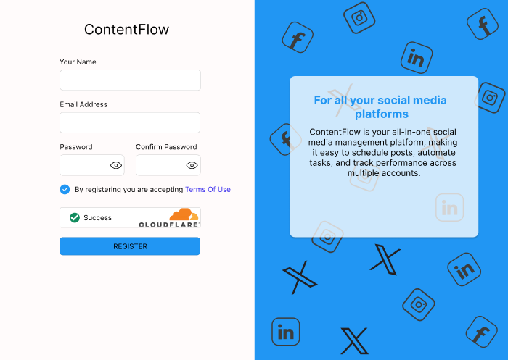

User can easily access and perform the activities of billing:

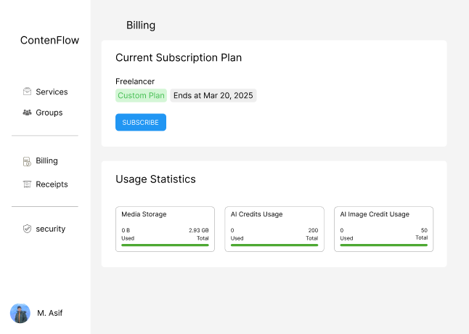

User can select the time and date for his post:

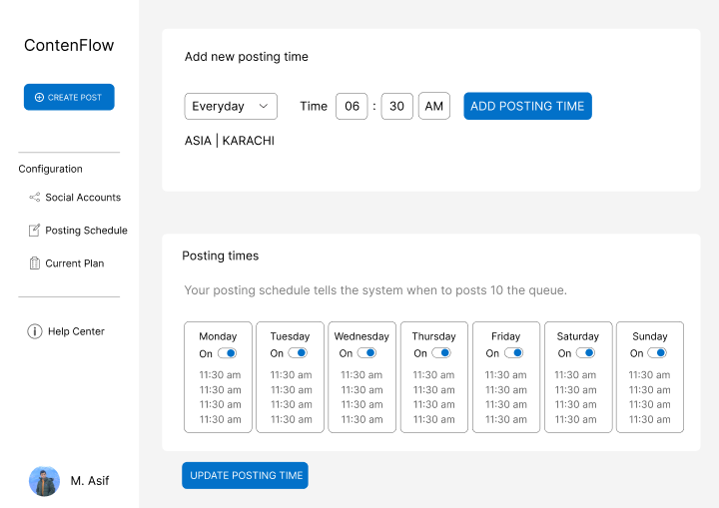

User can choose files to schedule a post:

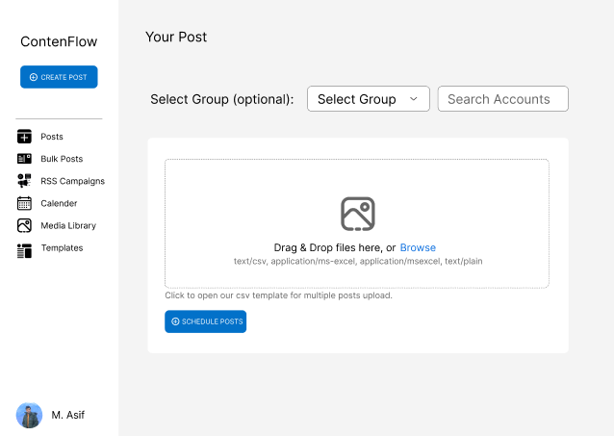

**UI-1**: The system shall follow Material Design principles for consistency across web and mobile interfaces.

**UI-2:** The system shall provide a dark mode and light mode toggle for user preference.

**UI-3:** The system shall use Font Awesome or Material Icons for all icons to maintain visual consistency.

**UI-4:** Button labels shall be action-driven, such as “Post Now,” “Edit,” and “Save Draft.”

**UI-5:** The system shall be optimized for 1920x1080 resolution but support responsiveness for mobile and tablet views.

**UI-6**: The system shall maintain a 12-column grid layout for structured UI elements.

**UI-7**: Every screen shall include standard navigation elements, including:

Main Menu (Dashboard, Drafts, Scheduled Posts, Analytics, Settings) Help Button Logout Button

**UI-8**: The system shall support keyboard shortcuts for common actions (e.g., Ctrl+S for saving drafts, Ctrl+P for previewing posts).

**UI-9:** The system shall use toasts or modal pop-ups for status messages like success, errors, and warnings.

## Software interfaces

**SI-1:** The system shall integrate with Facebook API, Instagram API, Twitter API, and LinkedIn API for automated post scheduling.

**SI-2:** The system shall connect to a Cloud Storage API (Google Drive, Dropbox) for importing media files.

**SI-3:** The system shall interact with a payment gateway (e.g., Stripe, PayPal) for handling subscriptions.

**SI-4:** The system shall store data in a MySQL/PostgreSQL database for managing user-generated content.

**SI-5:** The system shall connect to an AI engine for hashtag generation and content recommendations.

**SI-6:** The system shall allow exporting ads in PNG, JPEG, GIF, and MP4 formats using an image processing library (e.g., ImageMagick, FFmpeg).

## Hardware interfaces

**HI-1:** The system shall support mouse, keyboard, and touchscreen inputs for navigation and interaction.

**HI-2:** The system allow media uploads from a device’s internal storage, external hard drives, and connected USB devices.

**HI-3:** The system shall support smartphone cameras for capturing images/videos directly into the content editor.

**HI-4:** The system shall be optimized for Android and iOS devices when accessed via mobile browsers or PWA.

**HI-5**: The system shall support dual-monitor setups for multitasking while editing posts and scheduling.

## Communications interfaces

CI-1: The system shall send email notifications for successful post scheduling, failed post attempts, and subscription renewals.

CI-2: The system shall support SMS notifications for critical alerts (e.g., failed payments, account security issues).

CI-3: The system shall provide web push notifications for scheduled post reminders and analytics updates.

CI-4: The system shall support in-app messaging for admin announcements, support messages, and system updates.

CI-5: The system shall integrate with SMTP servers for outgoing transactional emails.

CI-6: The system shall use REST APIs for real-time updates and communication with third-party services.

# References

1. **Smith, J., & Lee, K. (2023). *Optimizing Automated Social Media Scheduling for User Engagement: A Machine Learning Approach*. *Journal of Digital Marketing Research, 45*(3), 112-126. DOI: 10.1007/JDMR-2023-045**
2. **Patel, R., & Zhang, Y. (2022). *AI-Powered Hashtag Recommendation Systems for Social Media Posts: A Sentiment Analysis Approach*. *International Journal of Artificial Intelligence Applications, 38*(2), 205-219. DOI: 10.1016/IJAIA-2022-038**
3. **Garcia, M., & Brown, L. (2021). *User Interface Guidelines for Multi-Platform Content Management Systems: A Comparative Study*. *ACM Transactions on Human-Computer Interaction, 29*(4), 410-432. DOI: 10.1145/THCI-2021-029**
4. **Nguyen, T., & Kumar, A. (2020). *Security Challenges in Social Media Automation: A Risk Assessment Framework*. *IEEE Transactions on Cybersecurity, 12*(6), 765-778. DOI:**

# Plagiarism Report

